Article
Predicting maize yield with a multilayer perceptron (MLP) model using multivariate field data
Péter Fejér^{1*}, Adrienn Széles¹, Péter Ragán¹, Csaba Juhász¹,Éva Horváth¹ and Tamás Rátonyi¹
Academic Editor: Firstname Lastname
Received: date
Revised: date
Accepted: date
Published: date
Citation: To be added by editorial staff during production.
Copyright: © 2025 by the authors. Submitted for possible open access publication under the terms and conditions of the Creative Commons Attribution (CC BY) license (https://creativecommons.org/licenses/by/4.0/).
¹ Institute of Land Use, Technology and Precision Technology, Faculty of Agricultural and Food Sciences and Environmental Management, University of Debrecen, H-4032 Debrecen, Böszörményi str. 138; e-mail: fejerp@agr.unideb.hu (P.F.); szelesa@agr.unideb.hu (A.Sz.); ragan@agr.unideb.hu (P.R.); juhasz@agr.unideb.hu (Cs.J.); horvath@agr.unideb.hu (E.H); ratonyi@agr.unideb.hu (T.R.);

* Correspondence: fejerp@agr.unideb.hu
Abstract: This study presents the findings of a multi-year maize field trial conducted on experimental plots between 2017 and 2019, focusing on the application of machine learning techniques to enhance yield prediction accuracy. A multilayer perceptron (MLP) neural network was employed to model the effects of agronomic treatments, environmental variation, and compositional traits. Six distinct modeling scenarios were developed to explore different combinations of input variables, with the grain yield of maize serving as the sole output parameter. These scenarios range from treatment-only models to those incorporating detailed quality and compositional data. The primary objective was to evaluate how well MLP models can capture the complex, nonlinear relationships influencing yield under varying conditions. The findings provide valuable insight into the role of machine learning in supporting decision-making for sustainable crop production, especially under diverse technological and environmental settings. The approach demonstrated here offers a foundation for more adaptable, data-driven strategies in agronomic optimization.
Keywords: machine learning; maize; ANN; MLP; neural network; yield; field trial; tillage, nutrient supply

1. Introduction
Maize (Zea mays L.) is one of the most globally important cereal crops, providing a vital foundation for food systems, livestock feed, and a range of industrial products. Its adaptability to various climates and production systems has made it a staple in both developed and developing countries. In many parts of sub-Saharan Africa, Asia, and Latin America, maize plays a central role in both caloric intake and household income [1]. Global maize production has exceeded 1.1 billion tonnes in recent years, underscoring its strategic role in global food security [2]. However, productivity remains highly variable due to climate change, soil degradation, and inconsistent agronomic management [3]. Improving maize yields through enhanced practices and technology remains a major priority for sustainable agriculture and nutrition security in the face of rising global demand [4].
In Hungary, maize holds a pivotal role in agriculture, ranking among the country's most extensively cultivated crops. Its versatility allows for diverse applications, including human consumption, animal feed, and ethanol production, underscoring its economic and strategic importance [5]. Hungary's favorable climatic conditions and fertile soils have historically supported robust maize yields, contributing significantly to both domestic needs and export markets. However, recent challenges such as climate variability and market fluctuations have impacted production levels, highlighting the need for adaptive strategies in maize cultivation. Maize in our country is a cornerstone of agricultural production, with the country ranking among the top maize producers in Europe. The crop's significance is underscored by its extensive cultivation and its role in both domestic consumption and external commerce. The University of Debrecen has conducted extensive studies on the effects of various agronomic factors, such as irrigation and fertilization, on maize yield and stability [6; 8]. For instance, research at the Látókép Experimental Station has provided valuable insights into how different production factors influence maize yield and yield stability, thereby informing best practices for cultivation in the region. These efforts are crucial in addressing the challenges posed by climate variability and in ensuring the sustainability of maize production in Hungary [7].
The prediction of maize yield using Multilayer Perceptron (MLP) artificial neural networks (ANNs) has garnered significant attention in recent agricultural research due to its potential to enhance accuracy and efficiency in crop management. For instance, Harsányi et al. (2023) demonstrate the effectiveness of the ANN-MLP-SC4 model, which achieved a high correlation coefficient (r = 0.98) and minimized errors, suggesting its capacity to support sustainable agricultural planning in Central Europe [9]. Similarly, the study by Adisa et al. (2019) reveals the applicability of ANN for maize yield forecasting across South Africa, emphasizing that various climatic factors play crucial roles in yield outcomes [10]. This aligns with findings from a study by Souza et al. (2023), which utilizes MLP to analyze public datasets and evaluate the impacts of climate and soil characteristics on maize productivity [11]. Moreover, Nyéki et al. (2019) emphasize the importance of spatio-temporal data in improving predictive accuracy, asserting that MLPs can facilitate a deeper understanding of the factors influencing maize yield during different growth periods [12]. This body of research underscores the capability of MLPs as robust tools for yield prediction, providing valuable insights that can guide policymakers and practitioners in agricultural planning and resource management.

2. Materials and Methods
The field experiment forming the basis of this research was conducted at the Látókép Crop Production Experimental Station of the University of Debrecen between 2017 and 2019. Located on the Hajdúság loess plateau, the site offers optimal conditions for complex, multi-factorial agricultural studies. The soil is a calcareous chernozem with a deep humus layer and excellent water retention capacity. The experiment is a polyfactorial, small-plot trial with three replications, allowing for the investigation of both the individual and interactive effects of tillage, fertilization, and irrigation. The layout and replication structure ensure statistically evaluable and reproducible results. Three tillage methods were applied: T1 – winter ploughing (27 cm): traditional deep tillage that incorporates organic matter into the soil; T2 – strip tillage (23 cm): a conservation practice minimizing soil disturbance and reducing energy input; T3 – ripping (45 cm): deep tillage to loosen lower soil layers, enhancing root development and water infiltration. Fertilizer treatments included three dosage levels: Control: N 0 – P₂O₅ 0 – K₂O 0 kg ^{ha-1}; Medium dose: N 80 – P₂O₅ 60 – K₂O 90 kg^{ha-1}; High dose: N 160 – P₂O₅ 60 – K₂O 90 kg ^{ha-1}. Additionally, the plots were divided into irrigated and non-irrigated sections to assess the effect of water availability. Table 1 summarizes the input variable combinations used in the six multilayer perceptron (MLP) modeling scenarios designed to predict maize yield. The scenarios were structured to reflect different thematic focuses, ranging from purely compositional parameters (SC1) to combinations of agronomic treatments and quality traits (SC5–SC6). This approach allows for the assessment of how various input types and their interactions contribute to model performance.

Table 1 Composition of the applied scenarios
Scenario | Input variables
SC1 | starch content, oil content, protein content, moisture content
SC2 | crop year, starch content, oil content, protein content, moisture content
SC3 | starch content, oil content, protein content, moisture content, hl-weight
SC4 | crop year, tillage, irrigation, fertilization
SC5 | crop year, tillage, irrigation, fertilization, starch content, oil content, protein content, moisture content
SC6 | crop year, tillage, irrigation, fertilization, starch content, oil content, protein content, moisture content, hl-weight

The composition of the input variables across the six MLP modeling scenarios is further illustrated in the chord diagram (Figure 1). This type of visualization provides a clear and intuitive representation of how each variable is distributed among the different scenarios. The diagram highlights that SC1–SC3 primarily include compositional traits such as starch, oil, protein, and moisture content, while SC4 focuses exclusively on agronomic factors like year, tillage, irrigation, and fertilization. SC5 and SC6 integrate both compositional and management-related variables, creating more complex input structures. The connections between variables and scenarios are proportionally weighted, emphasizing the role and recurrence of specific inputs across the experimental design.
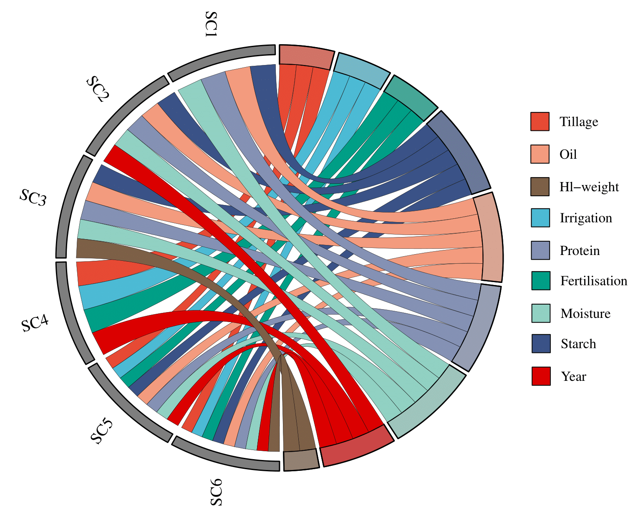

Figure 1 Chord diagram of the distribution of input variables within the different scenarios

In accordance with the continuous nature of the measured variables, all optional categorical data—such as crop year, tillage method, fertilization level, and irrigation status—were numerically encoded for each plot. Except for fertilization, which was treated as an ordinal variable due to its dosage-based structure, all other optional variables were treated as nominal factors. Each variable was defined as an input, while the yield was designated as the target (dependent) variable as the subject of prediction. Model runs were conducted separately for each scenario. Model names followed the format [model type]_[scenario number], e.g., MLP_SC1.

During each scenario run, measured variables were entered as covariates, categorical parameters (such as tillage or year) were treated as factors, and yield was consistently used as the dependent variable. By default, 70% of the dataset was used for model training and parameter tuning, while the remaining 30% served as a holdout set to evaluate predictive performance. As a result of running the model on each scenario, multiple information has been gathered, including the normalized importance of the input variables, which indicates their relative contribution to yield prediction. Additionally, the sum of squares error and relative error were calculated for both the training and testing datasets to assess model performance and generalizability. To further visualize predictive accuracy, scatter plots and ridgeline diagrams were generated, allowing for a detailed comparison between the distribution of predicted and actual measured values. To further evaluate and confirm the predictive efficiency of each scenario, several statistical performance metrics were calculated based on the predicted and observed yield values. These included the Pearson correlation coefficient (r) and the coefficient of determination (r²), both of which indicate the strength and proportion of explained variance in the predictions. The Nash–Sutcliffe efficiency (NSE) was used as a robust indicator of model accuracy, particularly in comparison to the mean of observed values. Additionally, common error metrics such as root mean square deviation (RMSD), mean absolute error (MAE), and mean absolute percentage error (MAPE) were computed to quantify the magnitude of prediction errors. Together, these indicators provide a comprehensive assessment of model performance across all scenarios.

3. Results

3.1. Normalized importance of the input variables

The contribution of individual input variables to the predictive performance of the MLP models was evaluated using normalized importance values derived from SPSS. Across the six scenarios, protein consistently emerged as the most influential input, reaching the maximum normalized importance (100%) in every case. Moisture also demonstrated high predictive relevance, particularly in MLP_SC1 and MLP_SC3, with values exceeding 98%, indicating its close relationship with yield variability under the studied conditions. Starch exhibited considerable importance in scenarios MLP_SC2 and MLP_SC3 (55.2% and 86.9%, respectively), suggesting its partial explanatory power for yield differences. Among the agronomic variables, crop year and tillage had substantial importance in MLP_SC4 (90.6% and 100%, respectively), but their influence declined sharply in MLP_SC5 and MLP_SC6. Irrigation and fertilization showed moderate to low importance across most models, with their role more prominent when combined with temporal and compositional variables. The Voronoi diagram (Figure 2) visually summarizes the distribution of variable importance across all scenarios, clearly illustrating which input factors dominated the predictive structure of each model configuration.

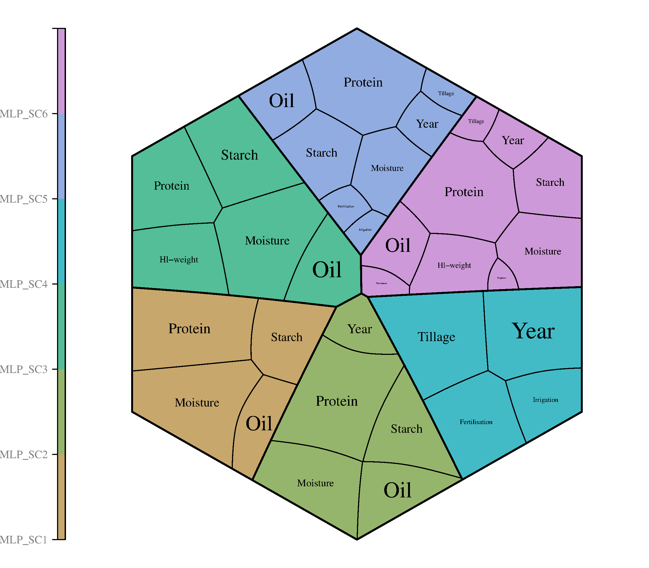

Figure 2 Relative importance of the input variables within the six MLP scenarios

3.2. Analysis of the predictive performance of the different scenarios

3.2.1. Ranking of the scenarios based on sum of squares error and relative error
To evaluate the predictive performance of the multilayer perceptron (MLP) models across different input configurations, each scenario was assessed using sum of squares error and relative error metrics for both the training and testing datasets. These measures provide insight into how accurately each model was able to learn from the data and generalize to unseen cases. The results are summarized in Table 2, highlighting the variation in prediction accuracy depending on the combination of input variables used in each scenario.

Table 2 Sum of squares error and relative error values for training and testing datasets across the six MLP scenarios
Scenario | Training |  |  | Testing
Scenario | Sum of squares error | Relative error | Sum of squares error |  | Relative error
SC1 | 216.313 | 0.472 | 92.865 |  | 0.505
SC2 | 176.473 | 0.392 | 80.499 |  | 0.447
SC3 | 221.735 | 0.478 | 90.050 |  | 0.462
SC4 | 442.502 | 0.982 | 175.549 |  | 0.937
SC5 | 166.541 | 0.371 | 72.367 |  | 0.346
SC6 | 160.339 | 0.347 | 76.986 |  | 0.433

The evaluation of the six MLP scenarios based on sum of squares error and relative error for both the training and testing datasets reveals notable differences in model performance. Scenario SC4, which exclusively incorporated agronomic variables (crop year, tillage, irrigation, and fertilization), yielded the weakest results, with the highest training (442.502) and testing (175.549) sum of squares errors, and correspondingly high relative errors (0.982 and 0.937). These results suggest that the exclusion of compositional variables significantly reduced the model's ability to generalize yield predictions. In contrast, SC1, SC2, and SC3, which focused on compositional traits such as starch, oil, protein, and moisture content—with SC2 additionally including crop year—achieved more favorable performance metrics. SC2 outperformed SC1 and SC3 with a training relative error of 0.392 and a testing relative error of 0.447, indicating that the addition of temporal information improved predictive accuracy. However, the best overall performance was observed in SC5, which integrated both agronomic and compositional inputs. It achieved the lowest testing sum of squares error (72.367) and the lowest relative error (0.346), suggesting that a balanced combination of input types led to the most accurate yield predictions. SC6, which also included all available input variables (including hl-weight), closely followed with similarly strong results, confirming the advantage of combining both environmental and compositional factors in predictive modeling.

3.2.2. Scatter plot analysis of MLP model performance

As a result of the analyses, scatter plots were generated to visually evaluate the relationship between the predicted and actual yield values across each MLP scenario (Figure 3). These diagrams provide further insight into the predictive quality and linear association of the models beyond numerical error metrics. The plots reveal a clear contrast in performance across the six scenarios. SC5 and SC6 demonstrate the strongest predictive alignment, as indicated by their high correlation coefficients (R = 0.80 and R = 0.79, respectively) and tight clustering of points along the 1:1 regression line. These results confirm the earlier findings based on error metrics, further validating the effectiveness of including both compositional and agronomic input variables. SC2 and SC3 also show strong correlations (R = 0.77 and R = 0.73), though with slightly more dispersion around the regression line, suggesting moderate prediction accuracy with minor over- and underestimations. SC1, with a correlation of R = 0.72, performs reasonably well but is less precise than SC2–SC6. The most limited predictive capability is observed in SC4, where the correlation is markedly lower (R = 0.18), and the scatterplot shows a weak linear relationship with substantial horizontal banding. This further supports the conclusion that agronomic variables alone are insufficient for reliable yield prediction in this context.
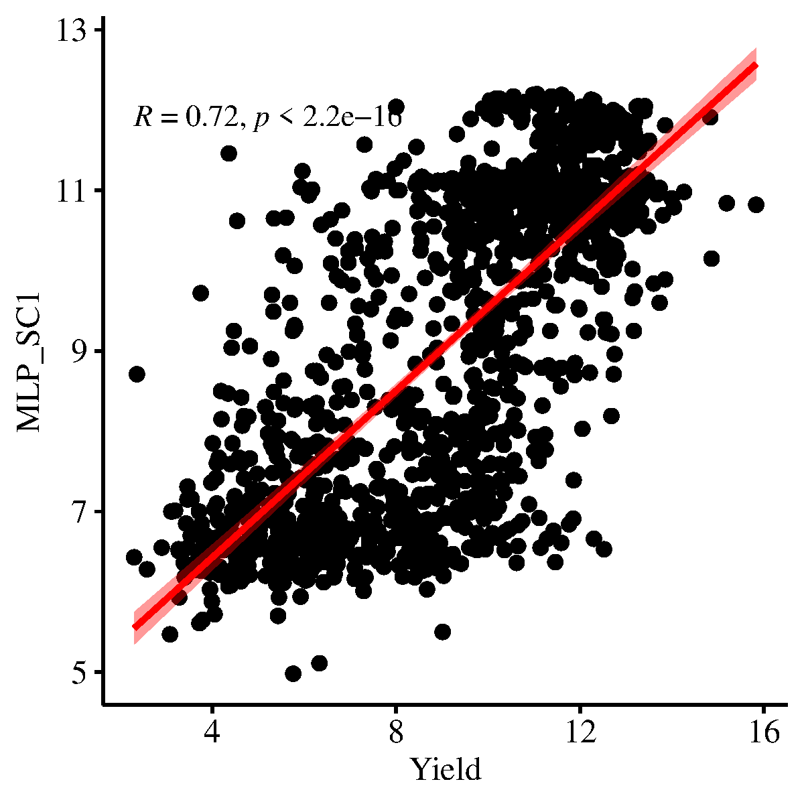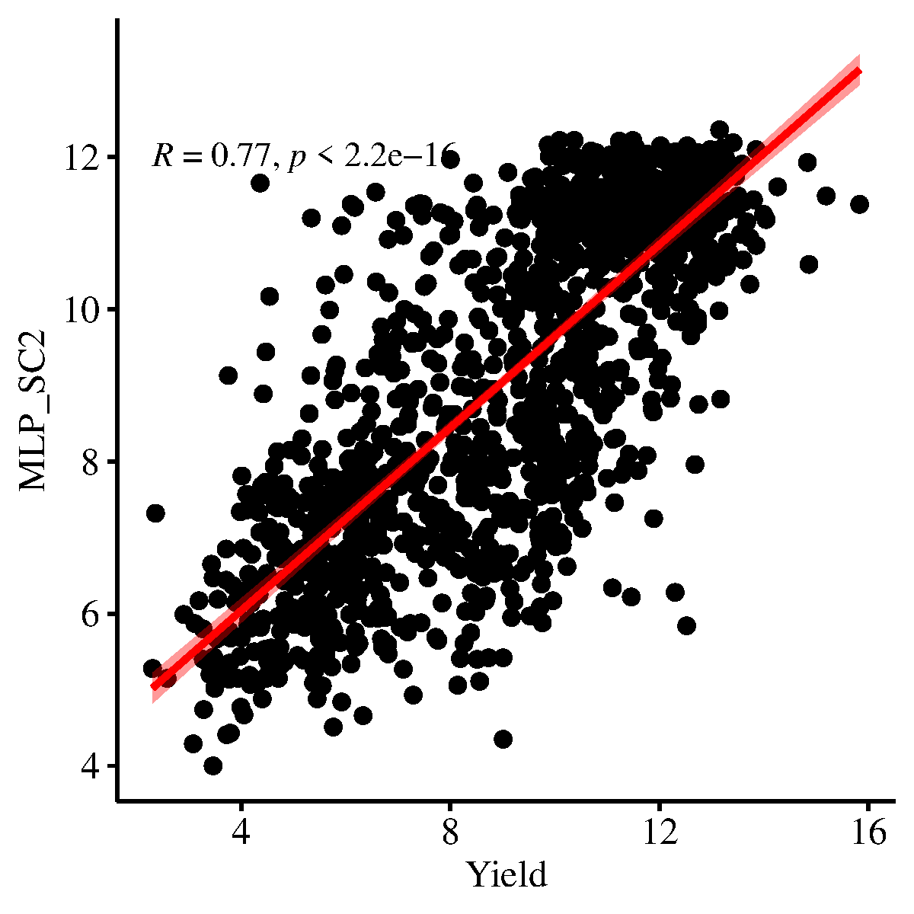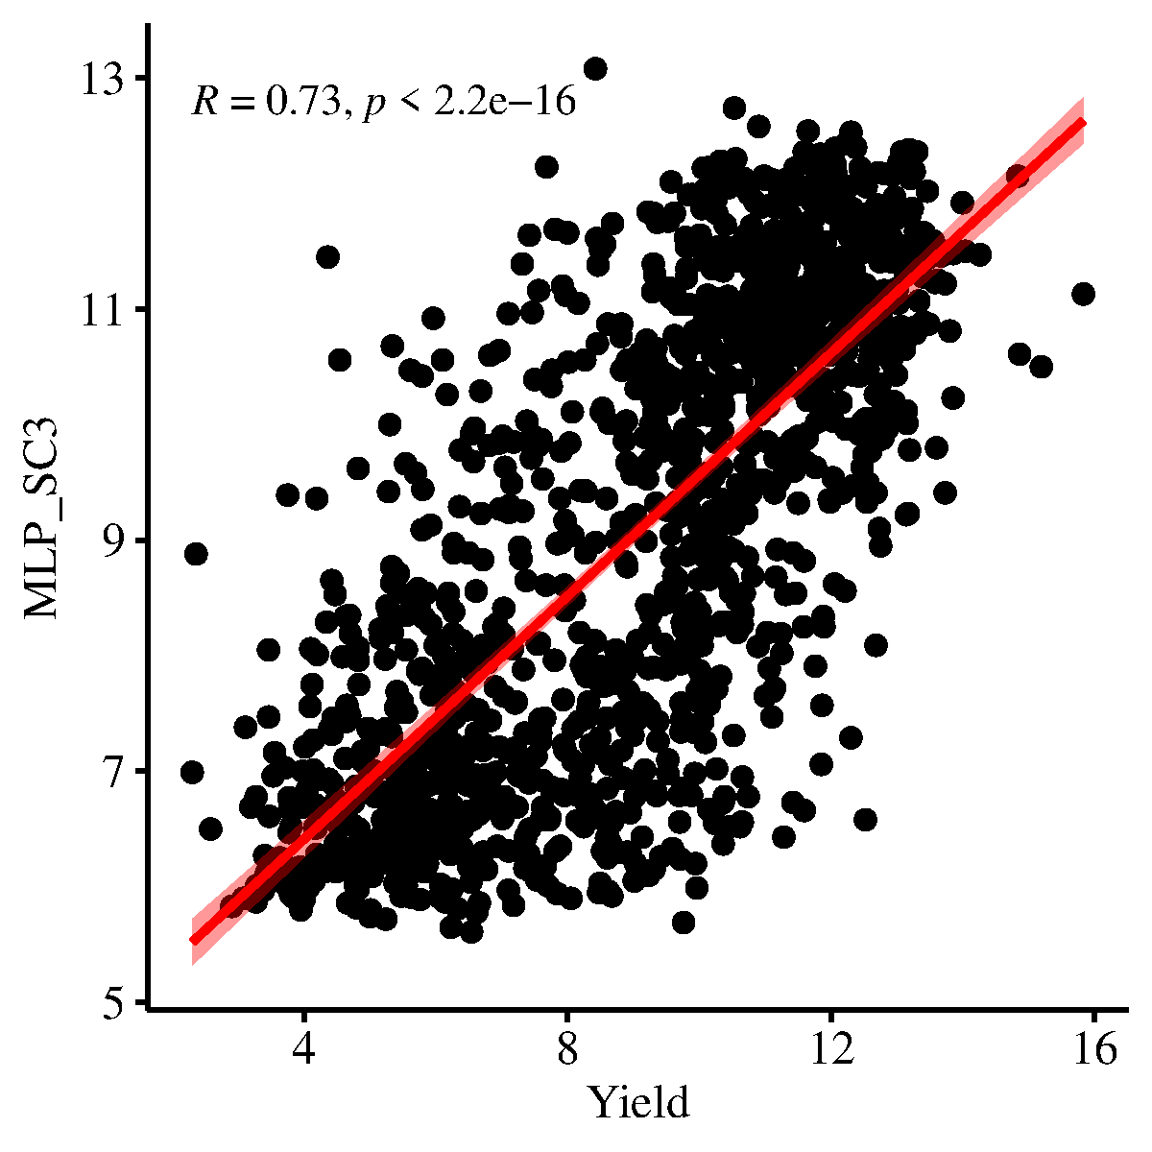
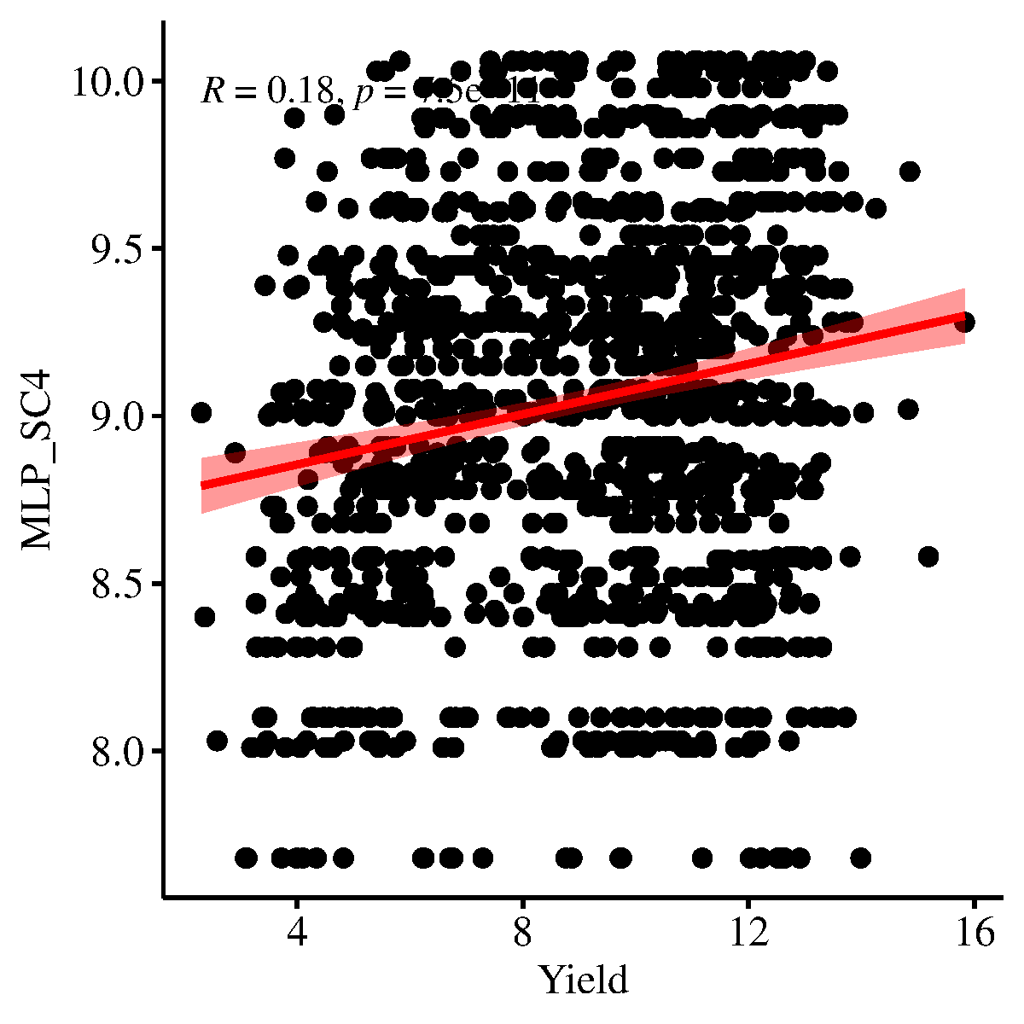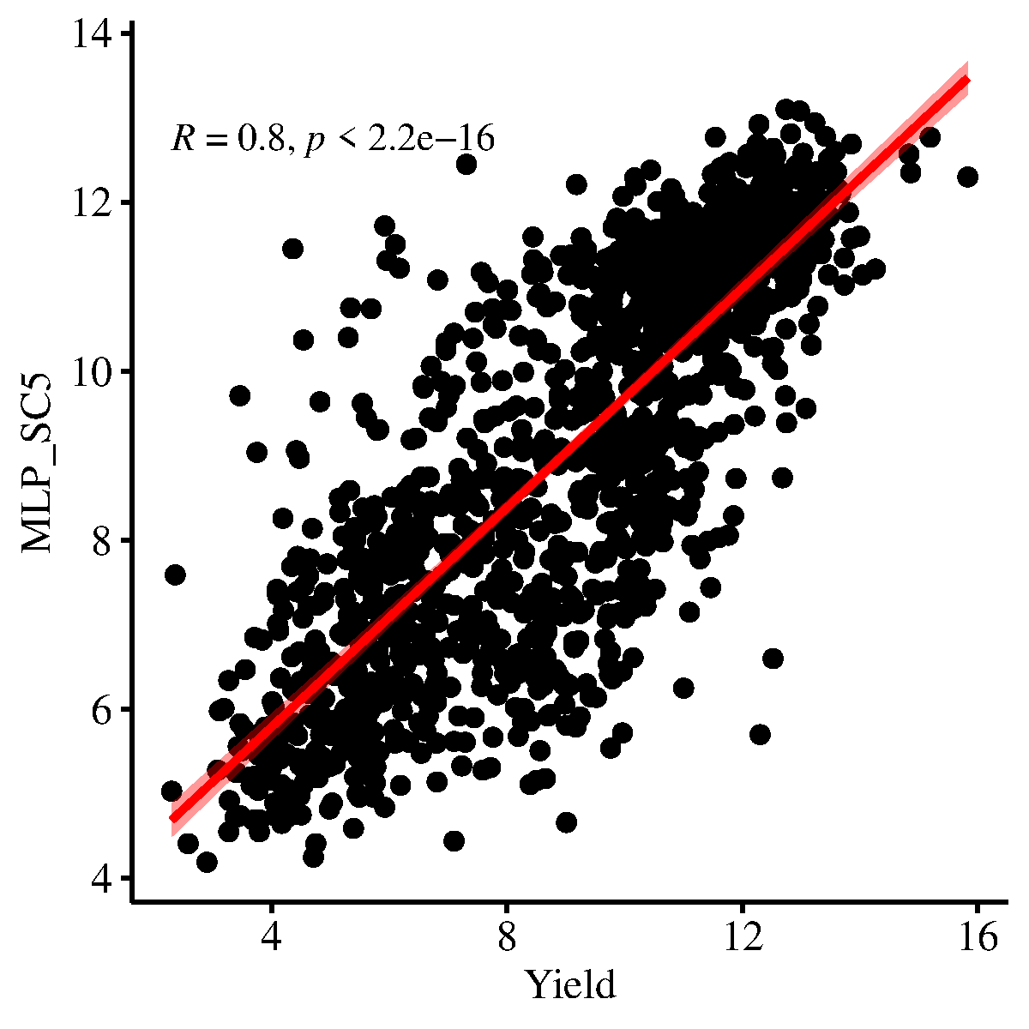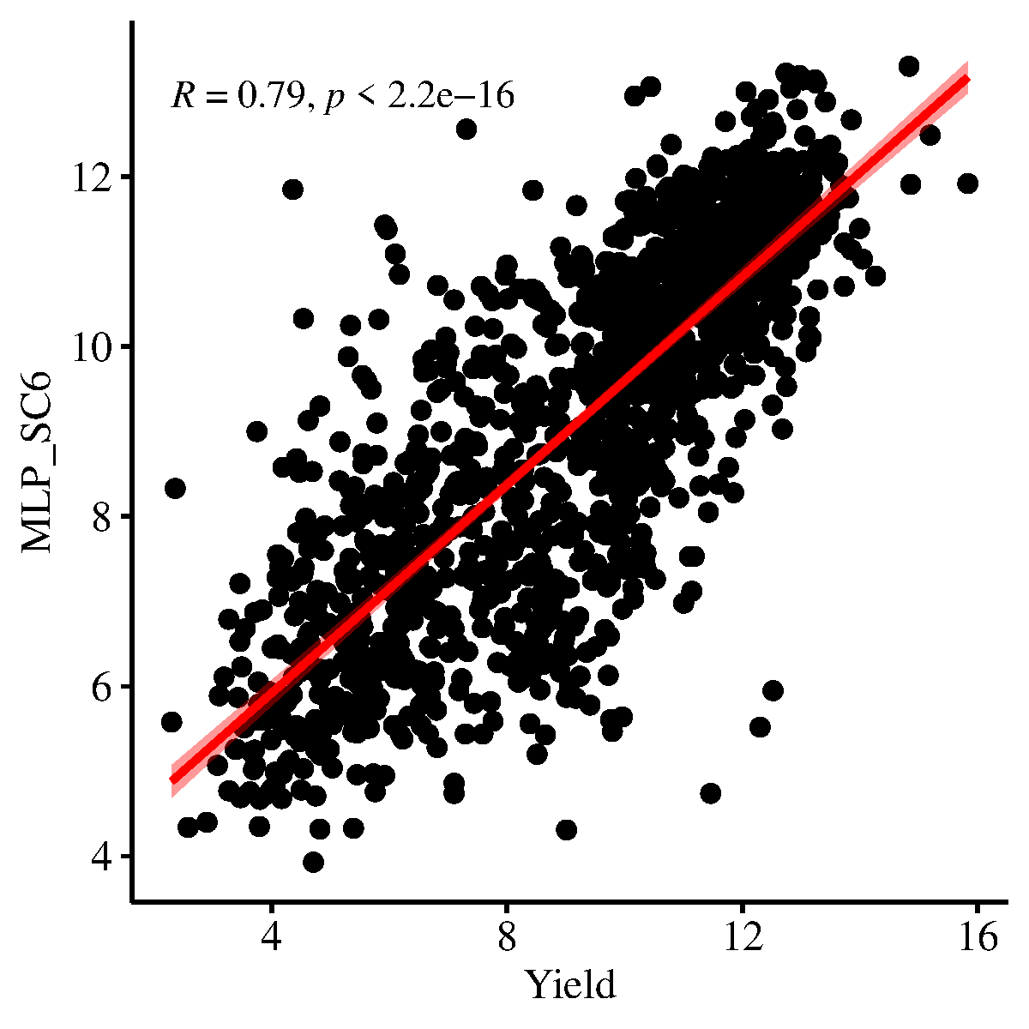
Figure 3 Scatter plots comparing predicted and measured maize yield values for each MLP scenario (SC1–SC6).

3.2.3. Evaluation of yield prediction accuracy through distribution plots
To complement the numerical and correlation-based evaluation of the MLP models, raincloud plots were used to compare the predicted and measured yield distributions across all six scenarios. These visualizations provide a detailed look at the accuracy, bias, and spread of the predictions in relation to the observed values. Each diagram includes kernel density estimations, boxplots, and scatter overlays, with the vertical red line connecting the medians of the measured and predicted distributions—offering a direct visual representation of prediction bias (Figure 4).
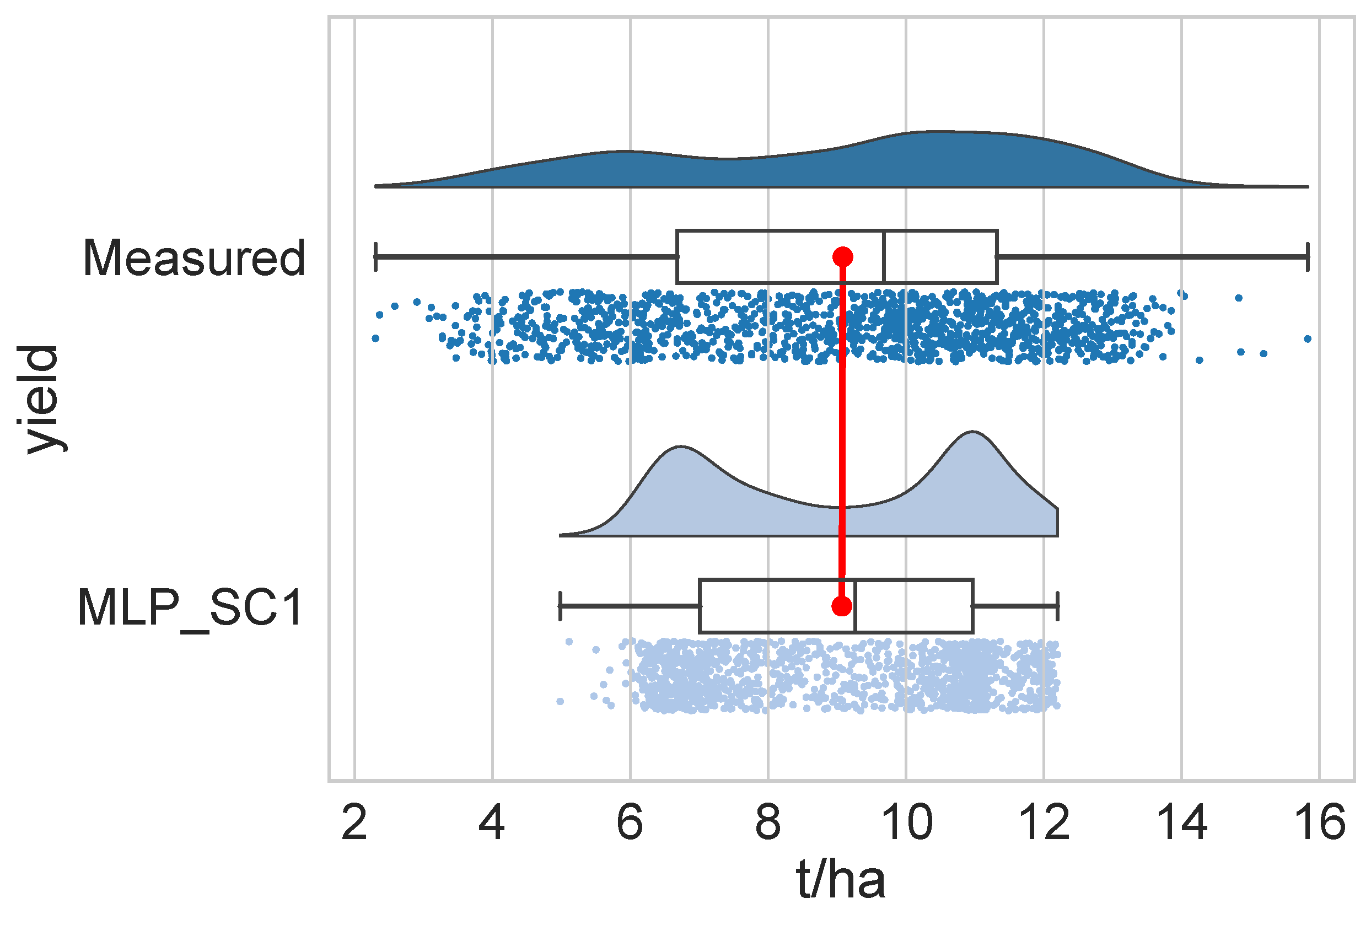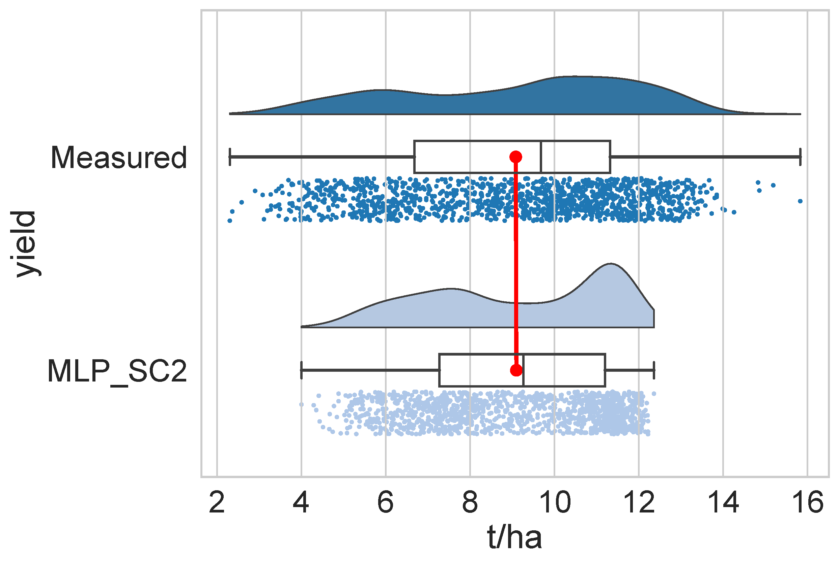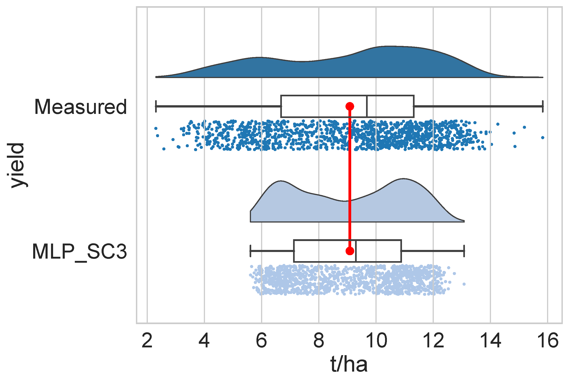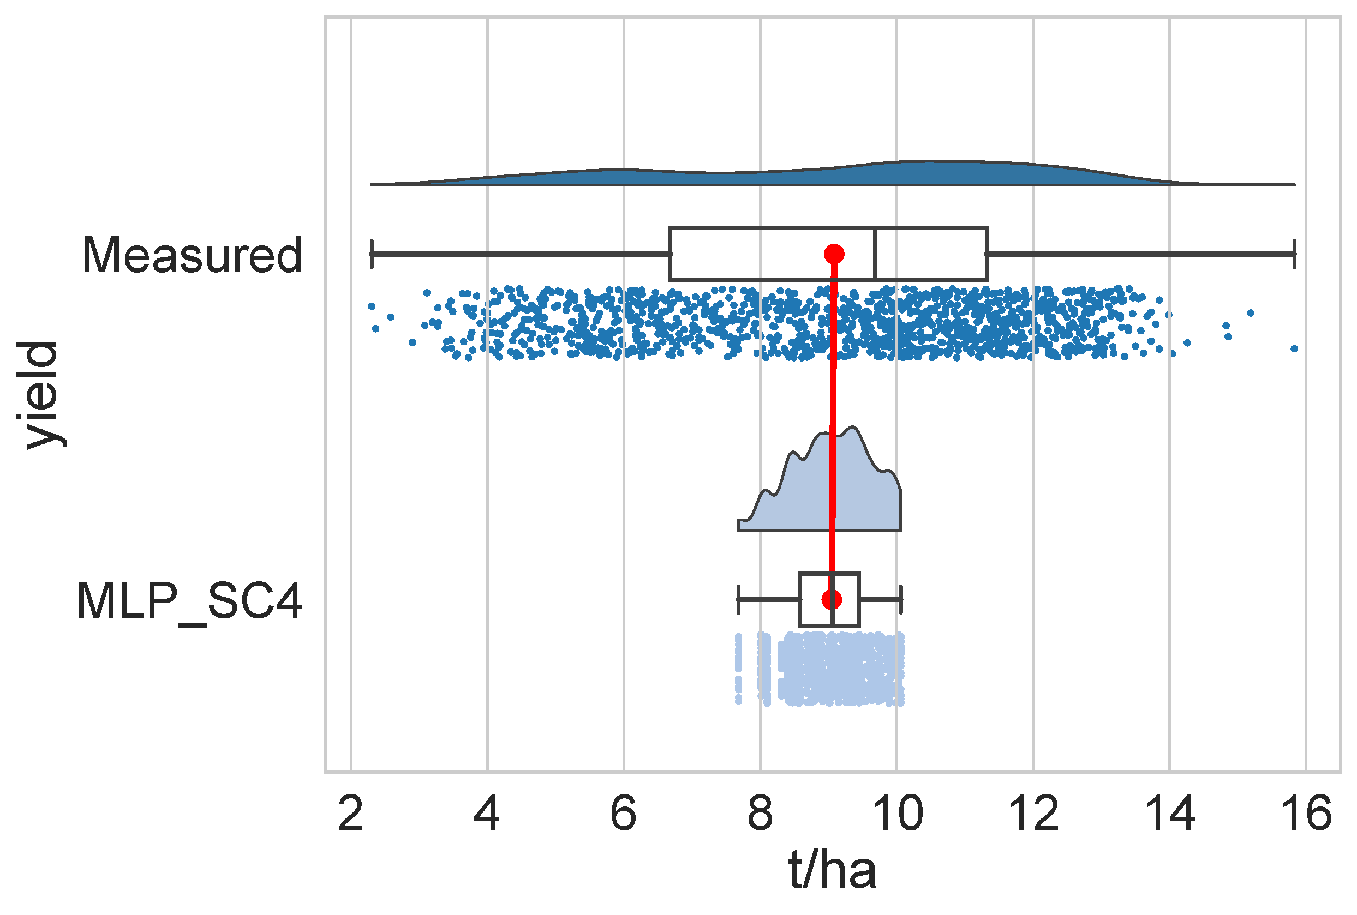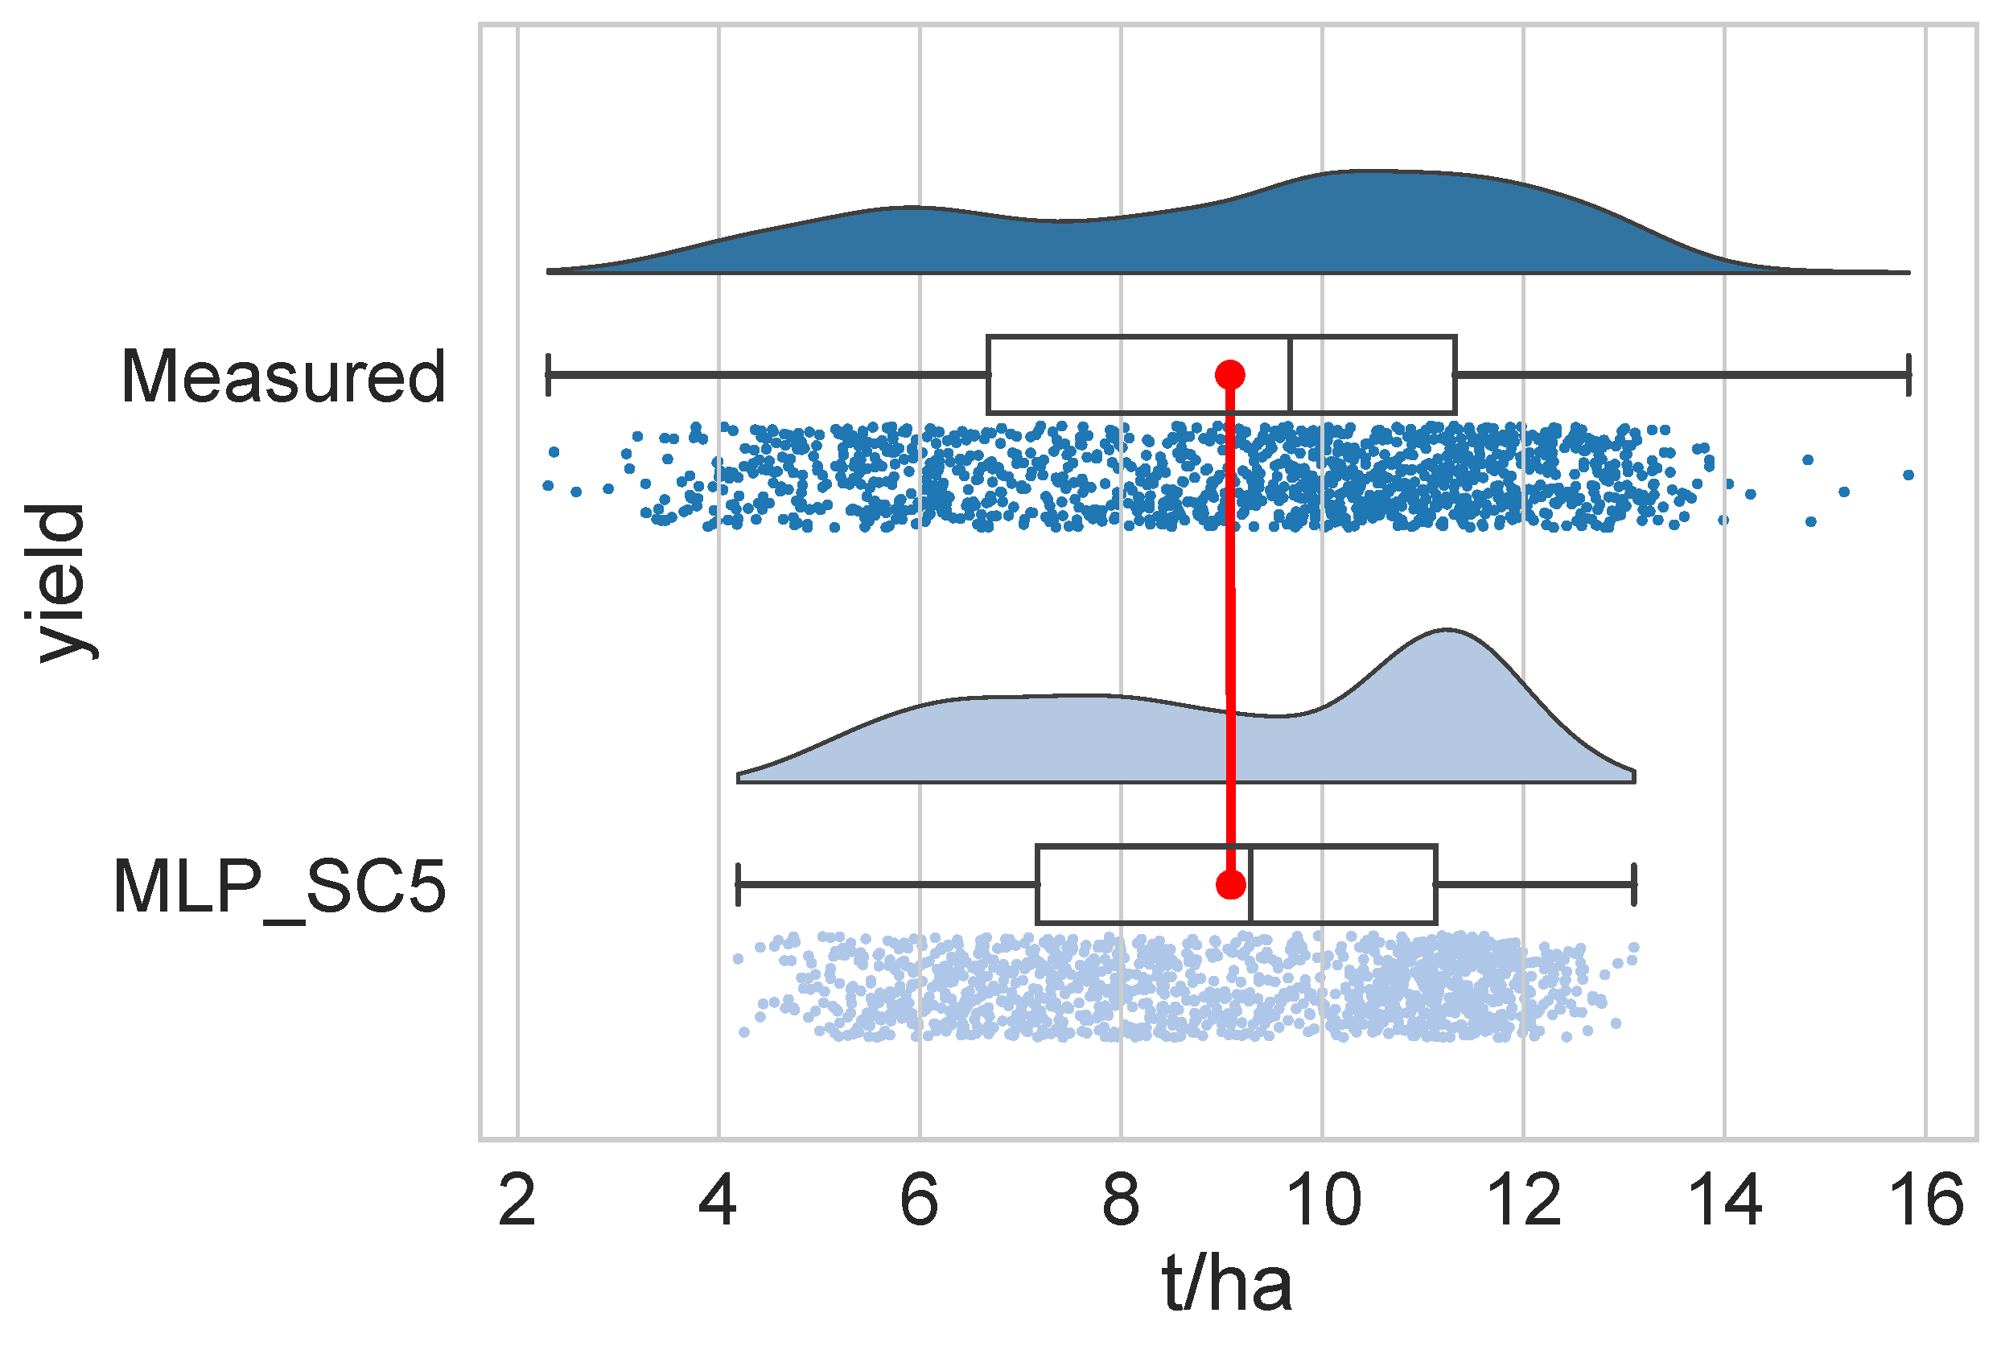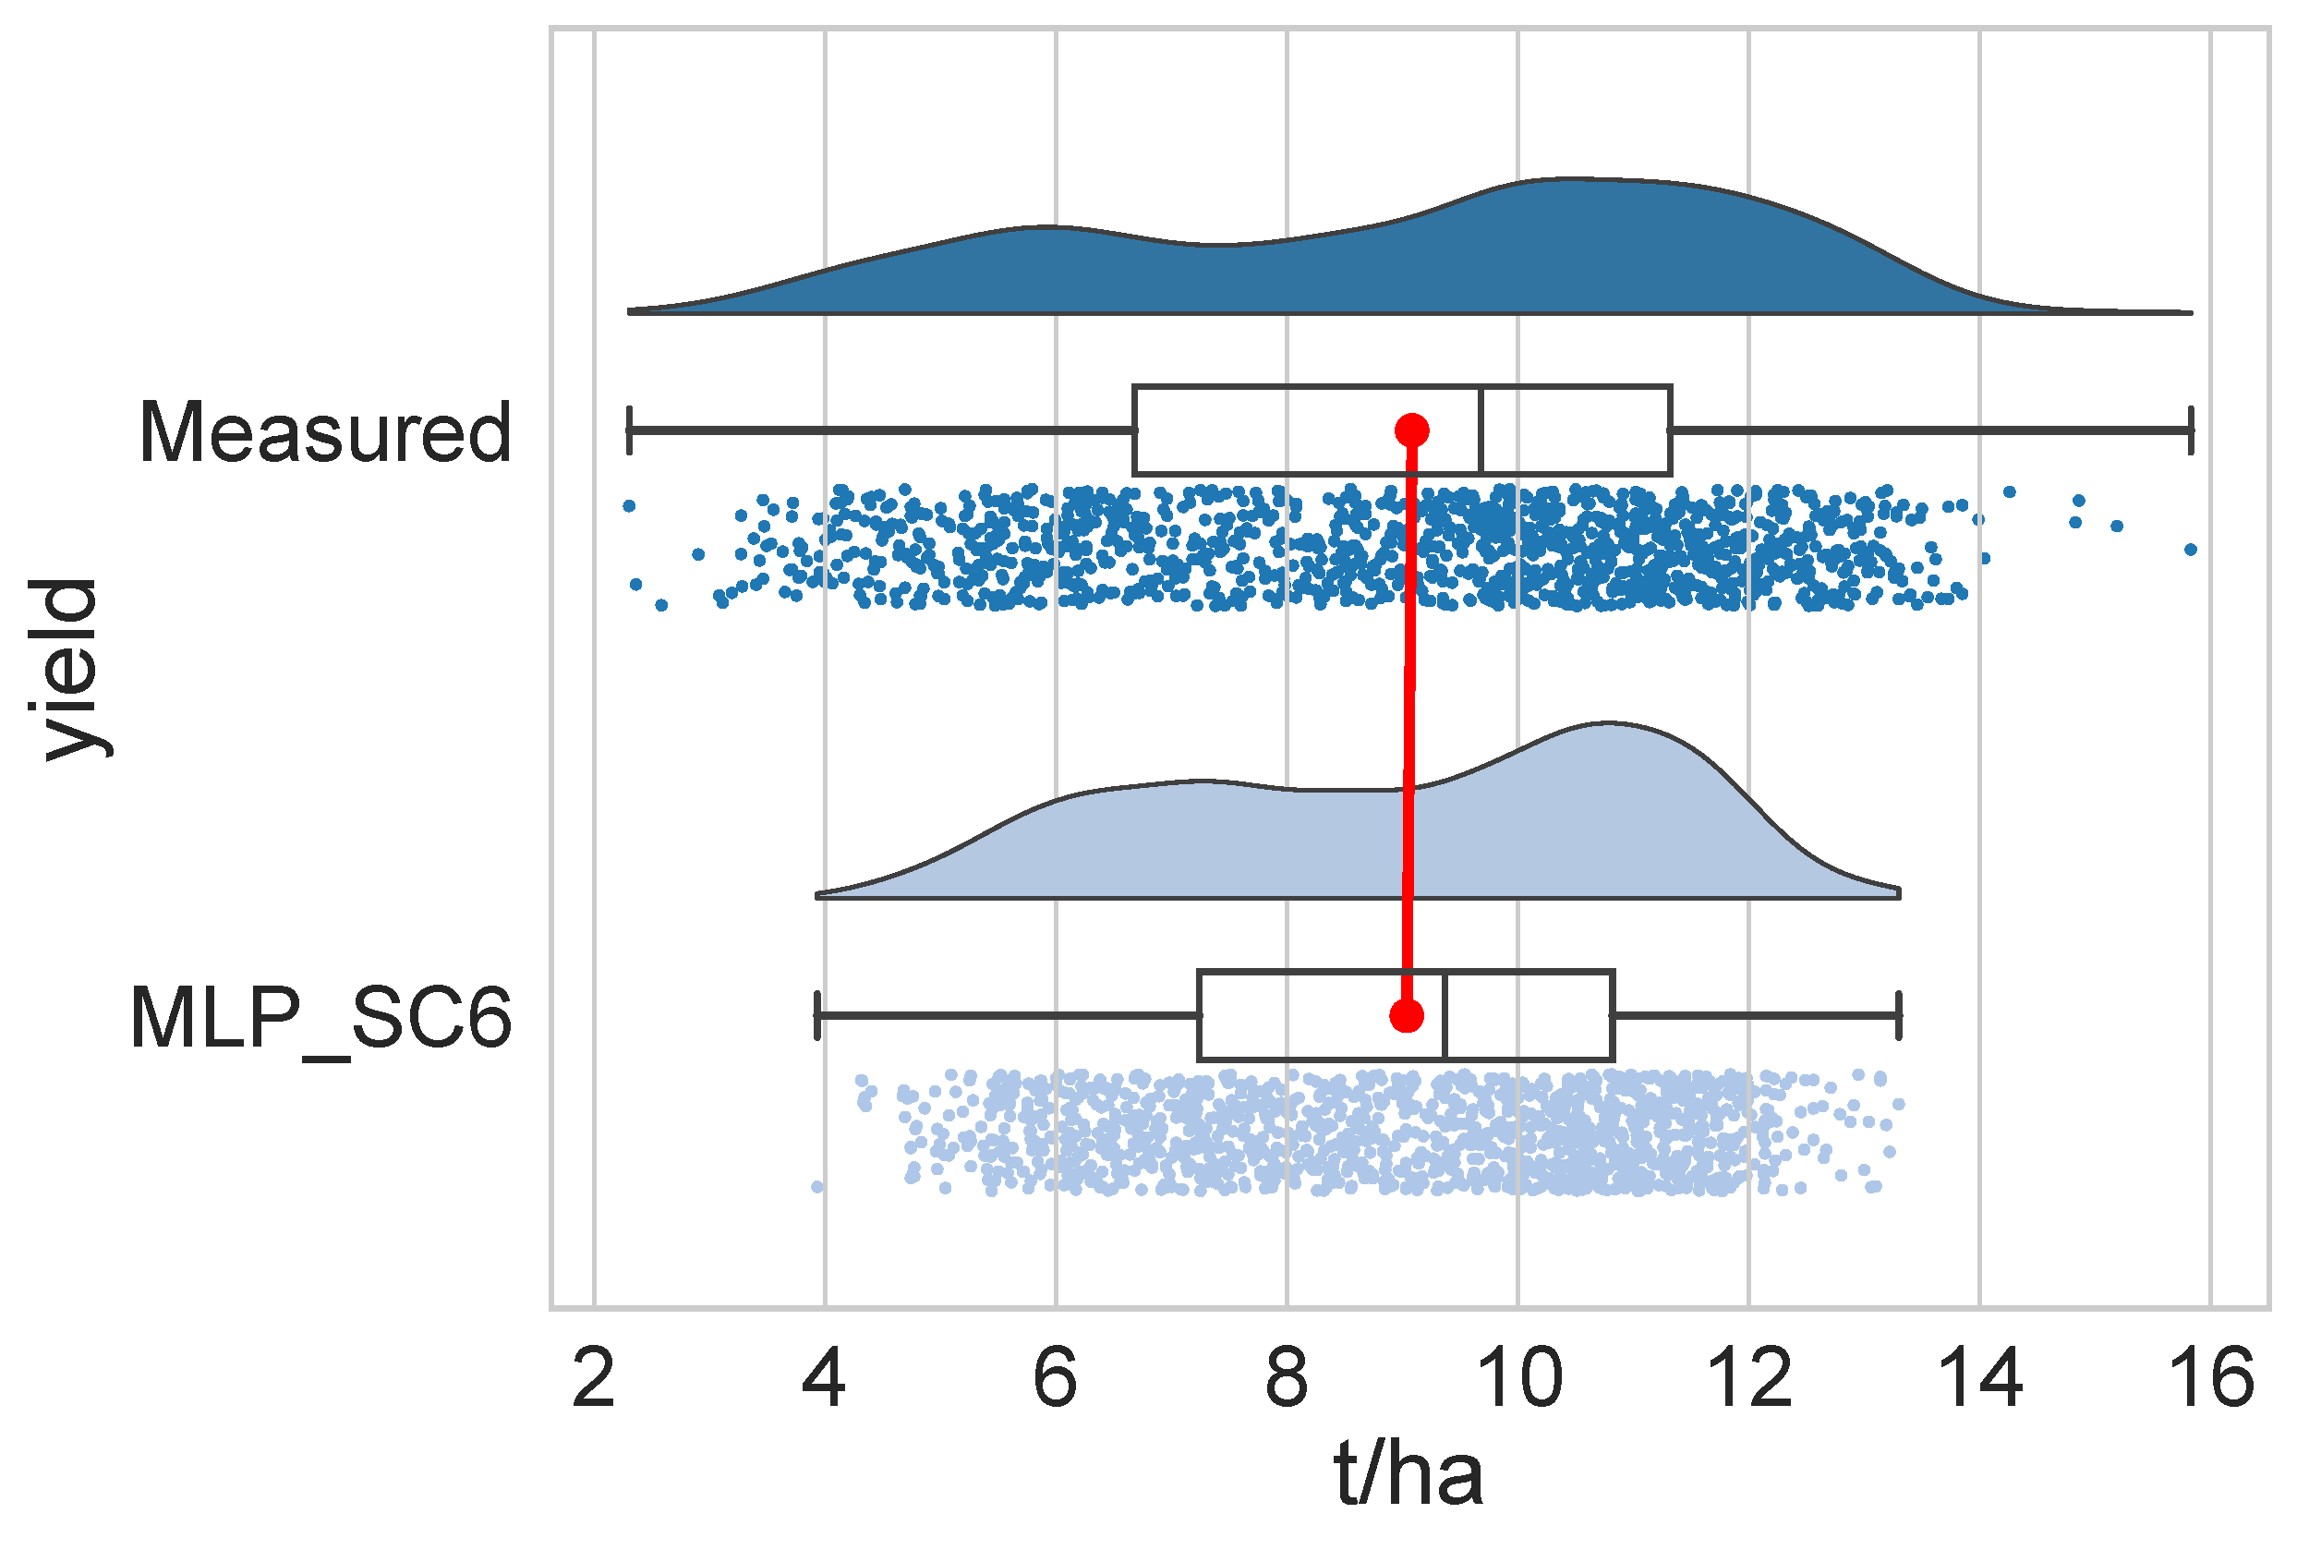
Figure 4 Comparison of the predicted and measured yield distributions across the six MLP scenarios using raincloud diagrams
The distributions for SC5 and SC6 again stand out with strong alignment between the predicted and measured values. Both scenarios exhibit nearly overlapping boxplots and density curves, with minimal vertical displacement between medians. This confirms not only the models’ predictive power (as reflected in the error metrics and correlation values) but also their ability to reproduce the shape and spread of real-world data. The distributions are slightly skewed in both cases but largely symmetric, suggesting consistent performance across yield ranges. In contrast, SC4 shows a substantial mismatch between predicted and actual yields. The predicted distribution is significantly narrower, with a visibly lower median and a tighter interquartile range, highlighting a systematic underestimation of yield and a lack of variability. This visual evidence strongly supports the earlier findings that agronomic variables alone do not sufficiently explain yield variability in this dataset.
SC1–SC3 show moderate alignment, with SC2 and SC3 offering better matching distributions than SC1. While the predicted and measured distributions differ slightly in shape and spread, the medians are relatively close, and the prediction ranges reasonably reflect the observed variability. These results are consistent with the error and correlation metrics reported earlier, where SC2 and SC3 outperformed SC1. Overall, these visual comparisons reinforce the conclusion that the inclusion of both compositional and agronomic variables, as seen in SC5 and SC6, leads to the most accurate and robust predictions of maize yield.

3.2.4. Statistical evaluation of predictive accuracy using performance indices
To further evaluate the predictive accuracy of the MLP models, several widely used statistical indices were calculated, including the Pearson correlation coefficient (r), coefficient of determination (r²), Nash–Sutcliffe efficiency (NSE), root mean square deviation (RMSD), mean absolute error (MAE), and mean absolute percentage error (MAPE). These metrics provide complementary insights into model strength, error magnitude, and predictive reliability across the six scenarios (Table 3).
Table 3 Statistical performance indicators for the six MLP scenarios, including Pearson correlation coefficient (r), coefficient of determination (r²), Nash–Sutcliffe efficiency (NSE), root mean square deviation (RMSD), mean absolute error (MAE), and mean absolute percentage error (MAPE).
Scenario | Performance indicators
Scenario | r | r² | NSE | RMSD | MAE | MAPE
MLP_SC1 | 0.720 | 0.519 | 0.519 | 1.912 | 1.538 | 0.21
MLP_SC2 | 0.770 | 0.593 | 0.593 | 1.757 | 1.398 | 0.19
MLP_SC3 | 0.726 | 0.527 | 0.527 | 1.896 | 1.531 | 0.21
MLP_SC4 | 0.180 | 0.032 | 0.031 | 2.712 | 2.330 | 0.32
MLP_SC5 | 0.798 | 0.637 | 0.637 | 1.660 | 1.294 | 0.17
MLP_SC6 | 0.794 | 0.630 | 0.629 | 1.677 | 1.317 | 0.18
Among all models, SC5 achieved the best overall performance with the highest values for r (0.798), R² (0.637), and NSE (0.637), indicating strong correlation, high explained variance, and excellent predictive efficiency. It also registered the lowest error values: RMSD of 1.66, MAE of 1.294, and MAPE of 0.17. Close behind, SC6 also performed strongly (r = 0.794, NSE = 0.629), confirming the advantage of combining both compositional and agronomic variables in yield prediction. SC2 and SC3 displayed intermediate performance levels. SC2 had r = 0.77, r² = 0.593, and NSE = 0.593, while SC3 showed slightly lower values across these indices. Both models maintained acceptable levels of accuracy and error, with MAPE values of 0.19 and 0.21, respectively. SC1 produced moderate results (r = 0.72, NSE = 0.519), but higher error metrics than SC2 and SC3, suggesting that excluding crop year data may have limited its prediction power. The weakest performance was again observed in SC4, with r = 0.18, R² = 0.032, and NSE = 0.031, alongside the highest RMSD (2.712), MAE (2.33), and MAPE (0.32). This indicates poor model fit and substantial deviation between predicted and observed values when only agronomic variables were used. The statistical results support earlier findings from the scatter plots and distribution analyses, reinforcing that integrated models using both environmental and compositional features (as in SC5 and SC6) deliver superior yield prediction performance.

3.2.5. Ridgeline plot analysis of predicted and measured yields

In order to complement the previous analyses of correlation, error metrics, and distribution comparisons, a ridgeline plot was generated to visually assess how well each MLP scenario replicates the overall distribution of measured maize yield values. This approach offers an intuitive summary of each model’s ability to capture the shape and spread of the target variable, thereby providing an additional layer of validation for model performance (Figure 5).
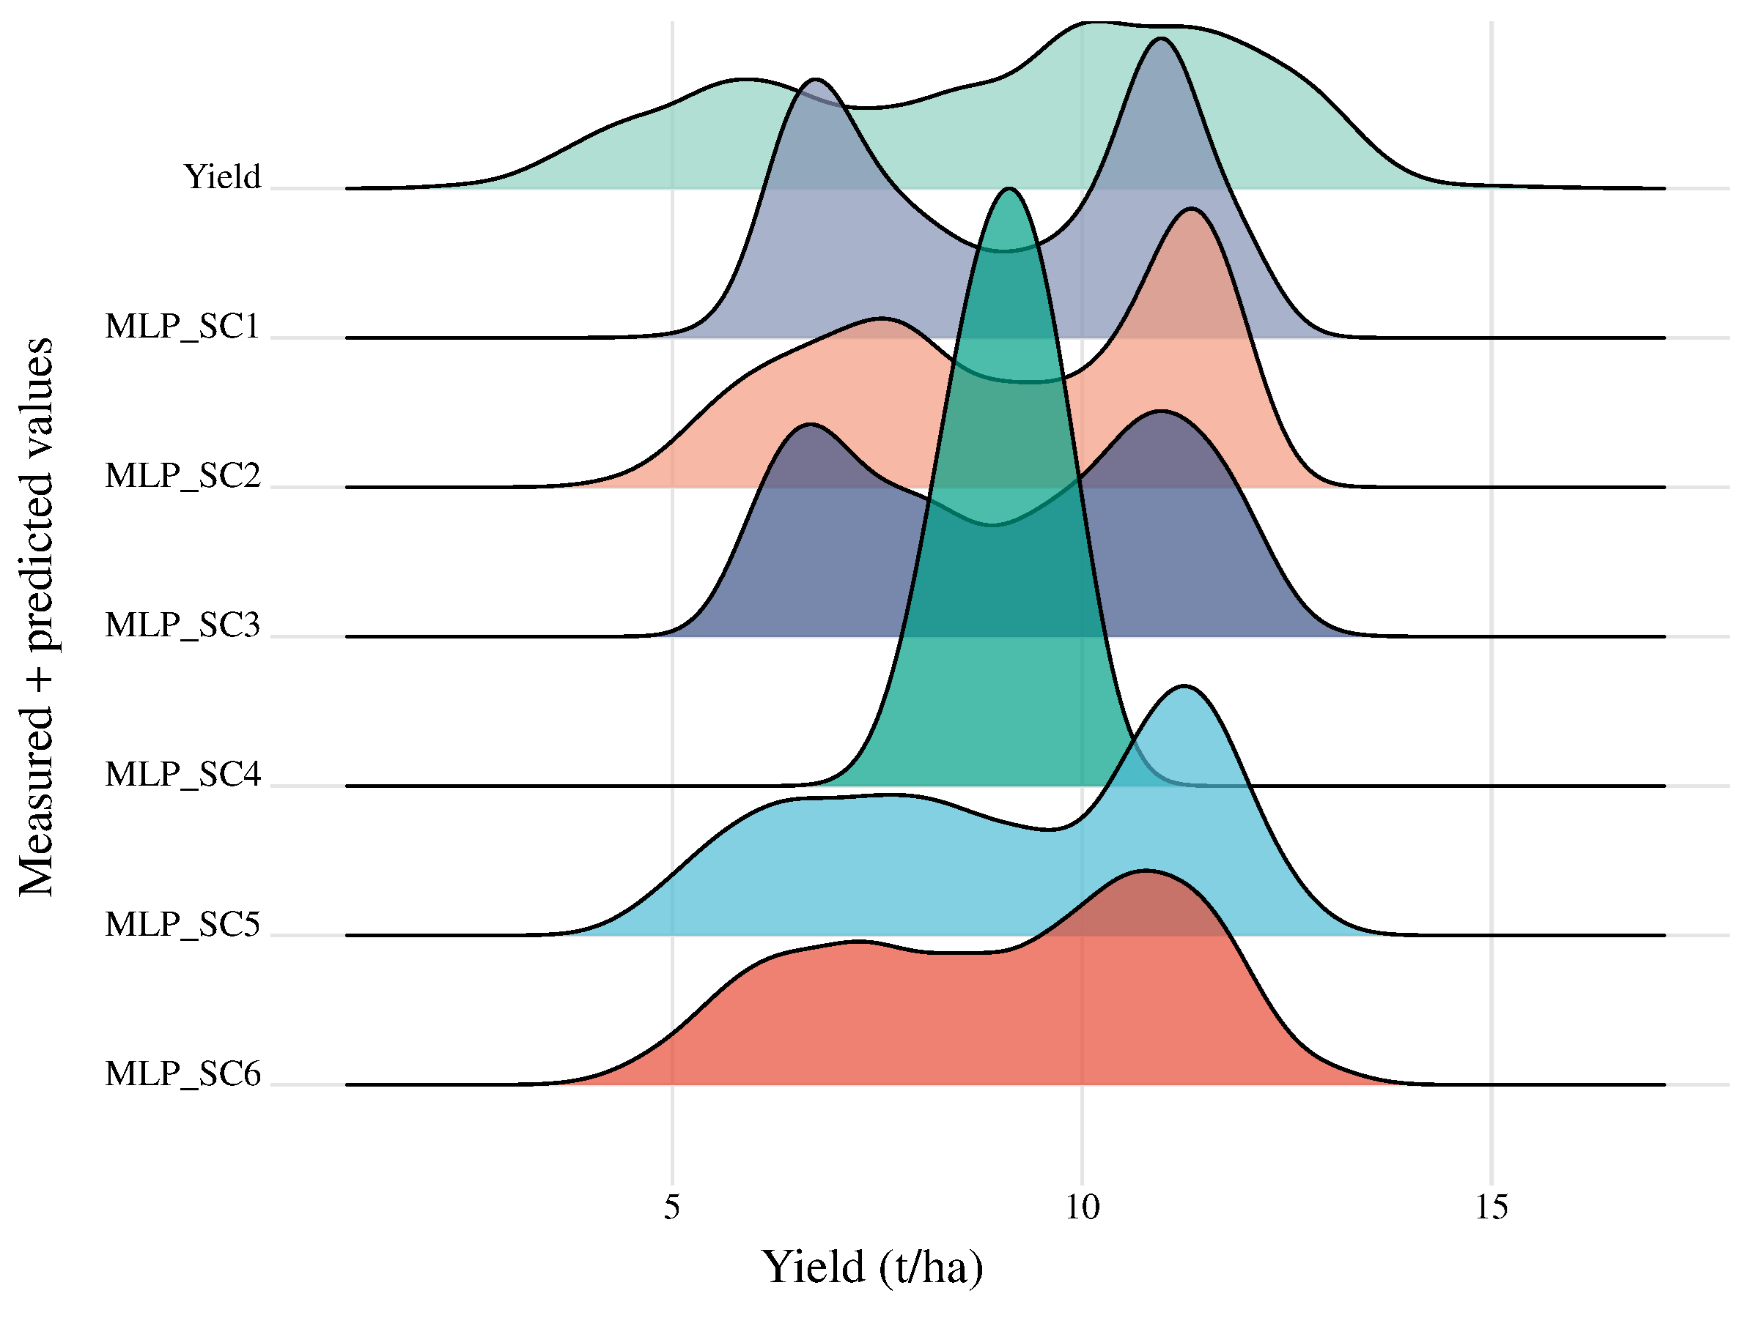
Figure 5 Ridgeline plot analysis of predicted and measured yields
The ridgeline plot in Figure 5 provides a visual comparison of the predicted yield distributions from each MLP scenario against the actual measured yield distribution. This visualization complements earlier numerical evaluations by highlighting how closely each model approximates not just the central tendency but the overall shape, dispersion, and modality of the yield data. The observed yield distribution (top line) shows a somewhat bimodal pattern, reflecting underlying variability in the dataset. MLP_SC5 and MLP_SC6 most closely replicate this shape, with their predicted curves aligning well with both the central peak and the spread of the measured values. This visual agreement supports the high correlation coefficients and low error metrics previously reported for these models, confirming their ability to reproduce real-world yield dynamics. MLP_SC2 and MLP_SC3 also show relatively good alignment, though with slight deviations in peak location and curve width, suggesting a minor under- or overestimation in certain yield ranges. SC1, while capturing the general spread of the data, deviates more in shape, particularly in its central region, indicating reduced accuracy compared to SC2–SC6. In stark contrast, SC4 displays a narrow and sharply peaked distribution, markedly different from the observed yield. This suggests that the model’s predictions were overly concentrated around a limited range, failing to capture the full variability of the data—consistent with its low r², high error values, and poor NSE score. Overall, the ridgeline plot reinforces the superior predictive performance of SC5 and SC6, while visually exposing the limitations of SC4 and the intermediate accuracy of SC1–SC3. This distribution-level perspective further validates the conclusion that incorporating both agronomic and compositional variables leads to more reliable and realistic yield predictions.
Finally, Figure 6 shows the architecture of the best performing scenario, showing the input layer which includes the applied variables, the hidden layer with the automatically determined number of neurons and the output layer which includes the variable that we predicted (yield).
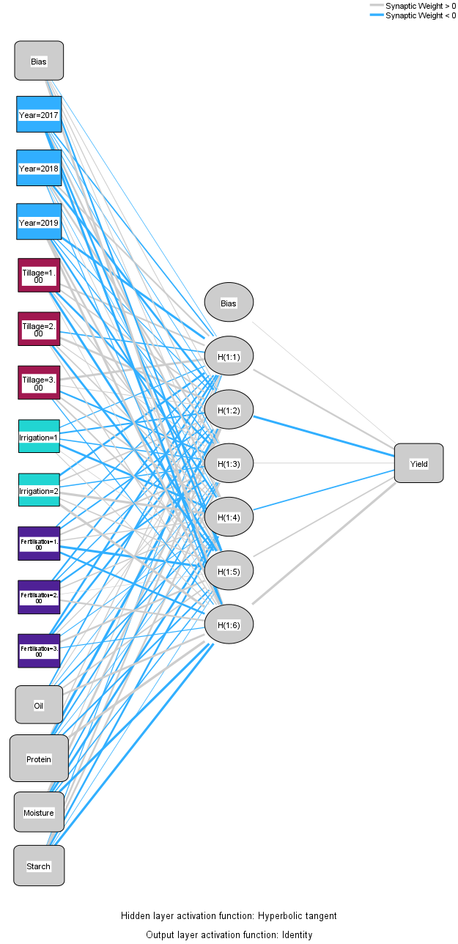
Figure 6 Architecture of the MLP_SC5 scenario

4. Discussion

The results of this study demonstrate that the predictive performance of MLP neural networks in estimating maize yield varies substantially depending on the combination of input variables. Models that incorporated both compositional traits (e.g., protein, starch, moisture content) and agronomic factors (e.g., tillage, fertilization, irrigation, year) consistently outperformed those based on only one type of data. This aligns with earlier studies highlighting the importance of integrating multiple data domains for yield prediction in complex agricultural systems (e.g., Shiferaw et al., 2011; Prasanna et al., 2019). Scenarios SC5 and SC6, which included the most comprehensive input sets, achieved the highest values for correlation coefficients, determination (r²), and Nash–Sutcliffe efficiency, while also exhibiting the lowest error indices (RMSD, MAE, MAPE). Their superiority was not only evident in numerical performance but also in the graphical analyses: scatter plots, ridgeline comparisons, and distribution diagnostics confirmed their robustness in replicating both central tendencies and variability in the observed yield data. These findings reinforce the hypothesis that multi-input neural networks are better equipped to capture the nonlinearities and interactions inherent in crop production environments.

On the other hand, SC4, which relied exclusively on agronomic variables, yielded significantly weaker results. Despite the known influence of tillage, fertilization, and irrigation on crop outcomes, the exclusion of biochemical or compositional indicators in this scenario likely limited the model’s ability to explain inter-plot variability. This suggests that while management practices are critical, their predictive strength is amplified when complemented by physiological or quality-related parameters. From a broader perspective, this study underscores the value of machine learning—specifically MLP networks—as a flexible and powerful tool for agricultural prediction. The findings support growing evidence that deep learning models, when supplied with diverse and well-structured input data, can offer meaningful contributions to precision farming and decision support systems. Nonetheless, limitations remain. The analysis was based on a small-plot experimental dataset from a single location and time frame. Expanding the spatial and temporal scope, as well as incorporating additional data types (e.g., remote sensing, soil characteristics, weather indices), could enhance model generalizability. Future research should also consider ensemble approaches that combine multiple model architectures, as well as the use of model interpretation techniques (e.g., SHAP values) to better understand variable importance in a more dynamic context. These directions may provide deeper insights into how predictive models can be translated into actionable agronomic strategies.

5. Conclusions
This study explored the applicability of multilayer perceptron (MLP) models in predicting maize yield using different combinations of compositional and agronomic variables. Among the six tested scenarios, those integrating both types of inputs demonstrated the highest predictive accuracy and consistency across multiple evaluation metrics. The results confirm that complex, multifactorial datasets can be effectively leveraged by neural network models to support yield estimation in field crop research. These findings highlight the potential of data-driven approaches in advancing precision agriculture and provide a strong foundation for future model development and field-level application.
Author Contributions: Conceptualization, P.F. and T.R.; methodology, P.F.; software, P.F.; validation, A.Sz., T.R. and Cs.J.; formal analysis, P.F.; investigation, Cs.J.; resources, É.H.; data curation, P.R.; writing—original draft preparation, P.F.; writing—review and editing, T.R. and A.Sz.; visualization, P.F. and É.H.; supervision, A.Sz. and P.R.; project administration, A.Sz.; funding acquisition, A.Sz. All authors have read and agreed to the published version of the manuscript.
Funding: Project no. TKP2021-NKTA-32 has been implemented with the support provided by the Ministry of Innovation and Technology of Hungary from the National Research, Development and Innovation Fund, financed under the TKP2021-NKTA funding scheme. Also, this paper was supported by the János Bolyai Research Scholarship of the Hungarian Academy of Sciences.
Conflicts of Interest: The authors declare no conflicts of interest. The funders had no role in the design of the study; in the collection, analyses, or interpretation of data; in the writing of the manuscript; or in the decision to publish the results.

References

- Shiferaw, B.; Prasanna, B.M.; Hellin, J.; Bänziger, M. Crops that feed the world 6. Past successes and future challenges to the role played by maize in global food security. Food Security 2011, 3, 307–327.
- Erenstein, O.; Jaleta, M.; Sonder, K.; Mottaleb, K.A.; Prasanna, B.M. Global maize production, consumption and trade: Trends and R&D implications. Food Security 2022, 14, 1295–1319.
- Wang, Y.; Wang, E.; Wang, J.; Liu, D.L. Impact of crop management practices on maize yield: Insights from a global meta-analysis. Agricultural Systems 2024, 210, 103543.
- Prasanna, B.M.; Cairns, J.E.; Zaidi, P.H. Maize agro-food systems to ensure food and nutrition security in the developing world. Global Food Security 2019, 21, 22–30.Author 1, A.; Author 2, B. Book Title, 3rd ed.; Publisher: Publisher Location, Country, 2008; pp. 154–196.
- Mizik, T.; Rádai, Z.M. The significance of the Hungarian maize production in relation to the Common Agricultural Policy. Review on Agriculture and Rural Development 2021, 10, 44–51.
- Széles, A.; Horváth, É.; Simon, K.; Zagyi, P.; Huzsvai, L. Maize production under drought stress: Nutrient supply, yield prediction. Plants 2023, 12, 3301
- Huzsvai, L.; Zsembeli, J.; Kovács, E.; Juhász, C. Can technological development compensate for the unfavorable impacts of climate change? Conclusions from 50 years of maize (Zea mays L.) production in Hungary. Atmosphere 2020, 11, 1350
- Széles, A.; Nagy, J.; Huzsvai, L. Effect of production factors on maize yield and yield stability. Acta Agraria Debreceniensis 2014, 56, 49–54.
- Adisa, O., Botai, J., Adeola, A., Hassen, A., Botai, C., Darkey, D., & Tesfamariam, E. (2019). Application of artificial neural network for predicting maize production in south africa. Sustainability, 11(4), 1145. https://doi.org/10.3390/su11041145
- Harsányi, E., Bashir, B., Arshad, S., Ocwa, A., Vad, A., Alsalman, A.,& Mohammed, S. (2023). Data mining and machine learning algorithms for optimizing maize yield forecasting in central europe. Agronomy, 13(5), 1297. https://doi.org/10.3390/agronomy13051297
- Nyéki, A., Kerepesi, C., Daróczy, B., Benczúr, A., Milics, G., Kovács, A.,& Neményi, M. (2019). Maize yield prediction based on artificial intelligence using spatio-temporal data. Precision agriculture '19, 1011-1017. https://doi.org/10.3920/978-90-8686-888-9_124
- Souza, P., Rezende, L., Duarte, A., & Miranda, G. (2023). Maize yield prediction using artificial neural networks based on a trial network dataset. Engineering Technology & Applied Science Research, 13(2), 10338-10346. https://doi.org/10.48084/etasr.5664
Disclaimer/Publisher’s Note: The statements, opinions and data contained in all publications are solely those of the individual author(s) and contributor(s) and not of PCP and/or the editor(s). PCP and/or the editor(s) disclaim responsibility for any injury to people or property resulting from any ideas, methods, instructions or products referred to in the content.

