Thematic Article |   Hungarian Educational Research Journal  2015, Vol. 5(2) 66–84  © The Author(s) 2015  http://herj.lib.unideb.hu  Debrecen University Press    DOI: 10.14413/herj.2015.02.05.
Integrated and Inclusive education of pupils with special educational needs in Slovakia
Mária Vajová & Jarmila Žolnová
Abstract
Slovakia became since 2008, the new Education Law (245/2008), which defines all levels of public education, the education of students with special needs students in the conditions and forms. This law guarantees equal educational opportunities for all students, which means also that the parents may request that a school receives for disabled children, and in such cases, the principal shall ensure that the conditions of teaching and education organization without barriers. Obviously, the new duties and obligations imposed by the Act on integrated / inclusive education constituted a major shift in how teachers are really unprepared. Creating the conditions for inclusive school education of pupils with disruptive behavior and disabilities requires knowledge of the development of a school’s success. Among the determinants of school success we include the interpersonal relationships of everybody involved with the school. A survey which studied relationships in the classroom using the analytical methods of A. N. Flanders indicates that teachers use a non-directive style of teaching with these students. Micro teaching analysis shows the percentage dominance of individual interpretation of the curriculum, giving assignments. Objective assessment of the underlying performance was to provide an overview of the current state of education in integrated education teachers' perspective. Understanding the attitudes of teachers regarding the cooeducation happened questionnaire in which 142 schools 368 teachers participated.
Keywords: Integrated and Inclusive education; Pupils with special educational needs; Special Education Programs; Student with mental disabilities

Theoretical and Legislative Background
The word integration comes from the Latin word integer which means complete, coherent. According to J. Jesenskeho (2000, p.23) educational integration is seen as a ”dynamic, gradually evolving phenomenon of the target individual, which leads to a relationship, communication and cooperation of all participants in the educational process under the same level of conditions throughout the course of their education and training with both sides actively cooperating in solving educational situations”. Educational integration includes any educational influence of different entities even those outside the classroom. The concept of educational integration is not widespread in the professional community. It is described in institutions under the name school integration.
A conceptual shift occurred after the publication of the meeting of the Committee for the Rights of the Child by the United Nations in the UNESCO in 1997: “Inclusion is an attitude that is based on the belief that all people are equal and should be respected. Inclusion is considered to be a never-ending process in which children and adults with disabilities get a chance to participate fully in all social activities which are open to people without disabilities.” (Vančova, 2005, p.259). Lechta (2009) recognises three ways of understanding inclusion among the professional community. Teachers will either identify inclusion with integration, or optimize the integration, or they understand inclusion as a higher level approach for pupils with special educational needs.
After 1990 school legislation in Slovakia underwent changes that opened up space for new learning conditions for all students without any discrimination. The Ministry of Education, Youth and Sports SR no. 29/1990Zb, which amended the Ministry of Education of the Slovak Socialist Republic no. 143/1984Zb, said that primary school students with mental disabilities or disruptive behavior could be entered into mainstream schools. This means that students with mental disabilities could be educated in special classes at primary schools. Education in special classes at selected secondary mainstream schools for pupils with visual, hearing and physical disabilities was introduced by The Ministry of Education, Youth and Sport SR no. 80/1991Zb. This legislation said that students with mental disabilities are able to prepare for a profession in vocational schools. The term individual integration of pupils with special educational needs is used in the legislative Act no. 29/1984Zb which relates to primary and secondary schools (Education Act) and was implemented by the 2004 Act no. 365/2004 Z.z about Equal Treatment in Certain Areas and Protection Against Discrimination, which amended and supplemented certain other laws (Antidiscrimination Act).
School integration was defined as the inclusion of pupils with special educational needs in special classes in mainstream schools or as integrated into classes with other pupils. Individual integration of pupils with special education needs are educated using an Individual Education and Training Plan. Law no. 245/2008Z.z about education and training (Education Law), which replaced the Education Act 1984, said that school integration considers the individual insertion of pupils with special education needs in classes with pupils without special education needs. Creating legislative options for connecting students in the classroom “without discrimination” is perceived as one of the components necessary for inclusive education.
Students with disabilities who are in compulsory education and vocational training are, in legislation, termed as “pupils with special education needs”. However, they are differentiated into pupils with mental disabilities, hearing impairments, visual impairments, physical disabilities, speech impairments, autism or other pervasive development disorders, or with multiple disabilities. In addition are pupils with illnesses or the medically fragile, pupils with developmental disorders (activity and concentration, delayed or uneven neurological development), students with disruptive behavior, pupils from socially disadvantaged backgrounds and pupils with talent.
For an objective indicator of the legislative component we can consider the data on school integration in primary and secondary schools issued by the Institute of Information and Prognoses of Education (modified table).
Table 1. The development of school integration of pupils with special education needs in primary schools
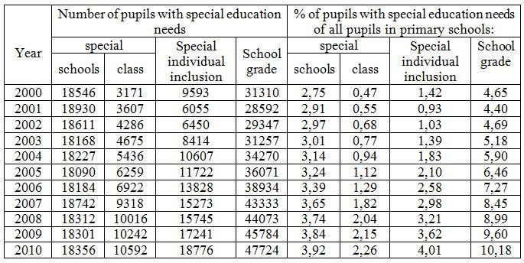
Legend: Table by Tekelova (2012)
Currently in Slovakia we have a combined system of education. Education can take place in special schools and in mainstream schools. In mainstream schools this is done in two ways. The first method is a special class which is opened for pupils with the same kind of disability or disruptive behavior. The second method of education takes the form of the individual insertion of pupils with special educational needs into a class of students without special education needs. Such a student is educated using an Individual Education and Training Plan, which is developed through the cooperation of the Centre of Special Education, Prevention and Counseling, and the legal guardians of the pupil with special educational needs. At the same time, the school should ensure that they secure professional personnel, the necessary materials, and the spatial and organizational conditions appropriate for the individual needs of the pupils in order to enhance the development of their potential to its optimum with the possibility that they can be inserted into society.
Cooperation between teachers and students leads to achieving educational goals, i.e. Educational attainment is a synergy of students and teachers (Prucha, Walterová, Mares, 1995). We can assume that the success of pupils at school is dependant on success in individual subjects. In addition to this, success depends on the level of the pupils characterisitics, their interests, their attitude and their academic competence (Baliga, 1994). The activity of pupils in lessons is influenced by physical factors such as attention, concentration, memory, will and so on. Student performance is aslo influenced by the teacher and his attitude to pupils, and this attitude to pupils is presented through communicative activities in the classroom and in individual communication with each pupil. If educational objectives are to be fulfilled, the teacher must bring educational reality closer to the pupil. This is an epistemological approach to the process of student learning, changing educational aspects so that the student passes from a zone of current development to the next zone of development, thereby advancing the full development of the personality of the pupil (Vygotskij, 1976). For pupils with special educational needs the teacher uses educational reality approaches based on planning "support measures and services to ensure optimal student learning" (Müller et al. 2001 45.). These approaches are documented in the individual education and training plan (IETP). The compilation of an IETP for pupils with special educational needs must be based on the school curriculum which defines specific requirements for education and comprehensive rehabilitation.
2. Education of students with mental disabilities in mainstream schools
Education of students with mental disabilities or mental disabilities in combination with other disabilities, is differentiated according to the degree of mental disability of the pupil into variant A, for pupils with mild mental disability, variant B, for students with moderate mental disability, or variant C, for pupils with severe or a profound degree of mental disability or for students with mental disabilities who also have other disabilities, who are holders of a disability card and are unable to be educated in variant A or B (educational program for students with intellectual disabilities ISCED 1).
The educational program is necessary for all forms of compulsory education. If a student with mental disabilities is integrated into individual classes which are intact, the teacher is responsible for developing the IETP. Understanding the individual characteristics of a pupil is one of the important requirements in the implementation of the principle of proportionality (Bajo, Vasek, 1994). Teachers who have a student with mental disabilities must have available all relevant information: medical, psychological, social, family information, previous learning outcomes etc. For the educational process to be successful it is necessary for the teacher to know the key characteristics of the pupil, which according to Lang and Barberichovej (1998, p. 39-40), are: the pupil's level of motivation (and respectively, the motivation on the part of the teacher for their success), the pupil's previous experience and educational attainment, the pupil‘s learning style, interests, relationship with classmates, and the expectations of the parents and society. In education we also apply special methods which have been developed for the use of special education needs teachers by amending the general teaching methods.
Bajo and Vašek (1994) indicate that the method of multiple repetition and excessive enhancement of information (for example by using information media), using multi-sensory methods, the optimal coding method, feedback, organising the curriculum, and the individual treatment method. The positive reinforcement method, in the form of praise and encouragement, elicits huge encouragement and a sense of achievement for students with mental disabilities, which for pupils without special education needs generally does not require attention.
The feeling of being rewarded, is very strongly related to system and process evaluation, which is used in the classroom. Praise and encouragement enables pupils to see their own progress and feel happy for it. When the teacher is giving instructions to students with mentally disabled pupils, they use a wide spectrum of means of communication: instructions must be simple and clear, use several ways to explain what they want, check pupils understanding, if necessary ask the pupils to repeat the instructions, engage fellow students or a teaching assistant (if there is one) to explain the instructions, divide roles and tasks into smaller parts, and appreciate the implementation of each phase when it is completed.
It is important that every teacher involved in a mentally disabled pupil‘s educational process should use the same approach. To achieve a good quality of cooperation between teachers, the teachers need to be involved in the assessment, planning and creating of effective conditions for learning for the student with mental disabilities. With regards to Hájková (2005), a teacher in the classroom with individually integrated pupils must know interpersonal strategies, learning strategies, designing educational practices, the developmental patterns of pupils without special education needs (SEN) and pupils with SEN, to react promptly to new situations in the educational process.
The school should be a supportive network that allows all participants of the integration program to help each other. Cooperation is therefore the teamwork of all professionals (teachers, SEN teachers, doctors, psychologists, speech therapists, and if necessary a teaching assistant), but also other interested parties (parents, peers, school staff). They create a so-called support network.
The support provided to an individually integrated pupil should lead to independence in life (Daniels, Stafford, 2002). Classrooms should offer good quality relationships that emphasize concern for the needs of others, space for autonomy and mutual support. An important role of the teacher is to create a positive atmosphere in the classroom. Teacher professionalism in creating a favorable climate is in finding a balance between the natural competitiveness of students in the teacher's favor. "In terms of teaching, this means preparing teachers to guide students to seek knowledge in experiential learning and motivate students towards teamwork and mutual assistance" (Resman, p. 171).
When working with pupils with mental disabilities it is a very important skill to communicate with his parents. Parents of these pupils are very sensitive to information about their child. If the parents sense that their child is being threatened or misunderstood this evokes a need for them to defend the child and question the teacher's knowledge (Švarcová, 2000, p. 90). An understanding teacher with the ability to empathize with the fate of the parents of the pupil becomes a source of social support. Emotional support is based on respect, honor, and the importance of parents. The providing of advice, assessing situation and instructing the parent has a cognitive dimension. Positively received support leads to family and school cooperation and positively affects the child's upbringing in the family environment.
3. Survey objectives and questions
In 2010 we conducted a survey to find out the structure of education for pupils with mental disabilities individually integrated into primary schools.
The survey is based on a quantitative strategy. The purpose of this survey is to analyse the structure of creative and humanistic education, which is orientated to changes of the relationships between teachers and pupils. Knowledge of the level of change from the traditional directive school system into a creative and humnistic school system. The application of these creative and humanistic concepts into practice leads to changes from the directive teaching style in the classroom into a classroom of active pupils, who freely express their opinions and attitudes.
Based on the above, we seek answers to the following questions: Does the teacher‘s approach vary when he talks to a child with SEN compared to a child without SEN? (i.e. Do teachers use a more direct approach for SEN students?) How much time do teachers spend directly with individually integrated pupils? Does the teacher individually explain to an integrated child about their new curriculum, tasks and commands?
Does the teacher engage pupils individually integrated into the learning process?
Does the individually integrated pupil have an individual education and training program?
3.1. Survey methodology of the educational style used by teachers for pupils with and without SEN
To find out whether teachers are using directive or indirective teaching methods we used Falnder’s analysis method (Zelina, 1998). We will focus on the time teachers spend directly with the integrated pupils individually. Activities are recorded when the teacher individually explains the lesson objective to the pupil, praises and encourages them, asks them questions, places orders and instructions, and when they criticize the integrated pupil. Whether individually integrated pupils are asked questions, whether they answer the questions, whether they follow the instructions and commands, and whether they speak spontaneously.
Flanders' method of analysis allows every third second of a lesson to be recordedand put into one of the following six categories with the acronym
OSTRAQ: O - silence, S – students speaking, T – teachers speaking, R - refusal, A - acceptance, Q – teacher‘s question. This allows us to compare the involvement of students or pupils without SEN and individually integrated pupils throughout the education process during one lesson.
The index of directive teachers (Id) vs. Non-directive teachers is calculated by the formula Id = (A + Q) / (T + R) A - the acceptance of students by the teacher, their praise and encouragement, guidance, positive call to action, a positive response to exercises
Q – The questions of the teacher to the pupils, and their commands and instructions
T – Teacher’s speech, explaining the commands, tasks and new topics, definitions, data relating to following lessons, lesson content, reading from textbooks R - rejection, correction, repair, negative evaluation, punishment, criticism of performance, cursing, evoking fear. If the directivity index is lower, the interaction between the teacher and pupils is more directive. If the directivity index is up to 0.49, the teacher is highly directive. If the directivity index in the range of 0.5 to 1.0 the teacher is moderately directive. If the index is higher than 1.0 the teacher applies a non-directive style of education (Flanders, 1970).
We recorded ten lessons in Slovak language and mathematics in grades 1-4 in various primary schools in eastern Slovakia. Every classroom had at least one individually integrated pupil with mental disabilities.
3.2. Data analysis and interpretation of survey results
During one teaching unit (lesson) we analyzed an average of 754 units of interaction between teachers and pupils without SEN. The minimum number of interacting units was 561, the highest number was 899. Between teachers and individually integrated pupils, we analyzed an average of 255 units of interaction ranging from 163 to 433 units.

Table 2
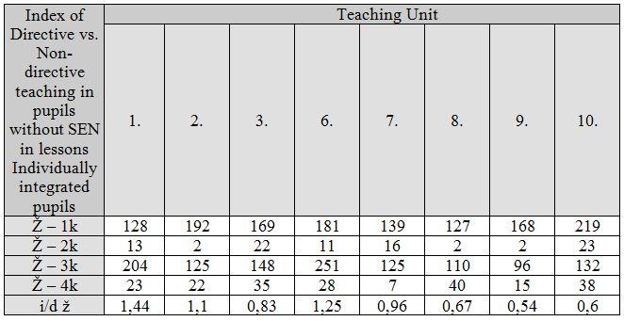
Legend:
F-1k – 1 pupils without SEN Category - teacher explains
F-2k - 2 pupils without SEN Category - teacher praises and encourages
F-3k - 3 pupils without SEN Category - the teacher asks questions, place orders and instructions
F-4K - 4 pupils without SEN Category - teacher criticizes
i / d ž – directive vs non-directive teaching
1st, 2nd, 3rd, 6th, 7th, 8th, 9th, 10th: Teaching units
We found that primary school teachers are predominantly moderately-directive to pupils without SEN. In 5 cases, these teachers were moderately directive and in 3 cases they were non-directive.
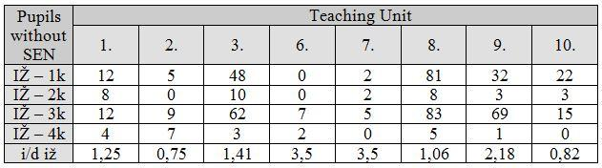
Legend:
IZ-1k - integrated pupils 1 Category - teacher explains individual
IZ-2k - 2 integrated pupils Category - teacher praises and encourages
IZ-3k - 3 integrated pupils category - the teacher asks questions, place orders and instructions
IZ-4k - integrated pupils 4 Category - teacher criticizes
i / d IZ - directive vs non-directive teaching
1st, 2nd, 3rd, 6th, 7th, 8th, 9th, 10th: Teaching units
We found that primary schools teachers are predominantly non-directive with integrated pupils with mental disabilities. In two cases the teachers were moderately prescriptive and in 6 cases they the teachers were non-directive.
Average of indexes i / d observed in the groups: The educational style of the teacher towards non-SEN pupils has a value of (i / d z) = 0.92 The educational style of the teacher towards SEN pupils has a value of (i / d Iz) = 1.78.
By comparing the directive and non-directive style of teachers with students with and without SEN in lessons we found that primary school teachers are predominantly moderately-directtive towards pupils without SEN. 5 of the 8 teachers were moderately directive and 3 were non-directive. When teachers worked with individually integrated pupils they were mostly non-directive. Two teachers were moderately directive, and five were non-directive.
Time spent directly with SEN pupils in one lesson was approximately 4 minutes and 15 seconds (255 seconds). The longest time was 8 minutes 50 seconds (530 seconds), and the lowest,40 seconds.
Graph 1. Graph showing the time spent directly with SEN students
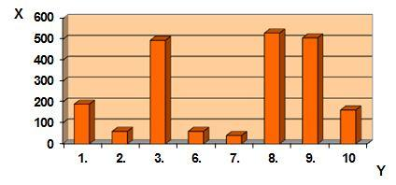
Legend: x axis - time measured in seconds, y-axis - teaching units
Time which teacher spends with integrated pupil, indicated in seconds
The time teachers spent individually with integrated pupils was dedicated to the explanation of the new curriculum or an explanation of assignments or tasks. This time was approximately 1 minute and 8 seconds (68 seconds). The highest measured time was 3 minutes and 43 seconds (223 seconds). The lowest time was zero seconds, in the 4th and 5th teaching unit (In graph 2 these teaching units are not shown).
Graph 2. This graph shows the time in seconds that teachers spent explaining the lesson objective to SEN pupils.
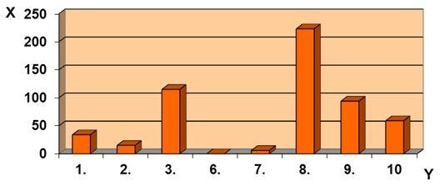
Legend: x axis - time measured in seconds, y-axis - teaching units
Time in seconds that teachers spent explaining the lesson objective to SEN pupils.
In a questionnaire we found that five of the seven teachers had been explaining lesson objectives from previous lessons in the following lessons. Those lessons were arts, music and practical classes. Involvement of non-SEN students in the teaching process mediated by teachers was, on average, 19.6%. However, the involvement of SEN pupils was on average only 10%. This data was obtained by calculating the percentage of the data obtained by Flanders' methods of observation.

Graph 3. The involvement of students in the learning process mediated by the teachers
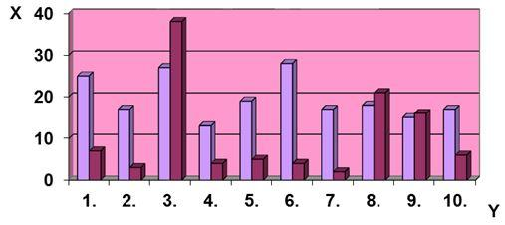
Legend: x-axis - the involvement of pupils reported as a percentage, y-axis - teaching units
- Intact pupils - Integrating students with mental disabilities Individual student involvement in the learning process means that the pupil himself spontaneously talks, expressing their ideas and suggestions, or the response exceeds the requirements of the teacher.
Individual involvement of non-SEN pupils was on average 1.9% of the teaching process, integrated engagement of students with mental disabilities was an average of 0.8%. The engagement of students in the learning process during our study, the teaching units and their percentage difference, is outline in the following chart. We found that teachers engage students in intact learning process twice as often as integrated pupils with intellectual disabilities and intact while students are engaged separately four times more than integrating students with intellectual disabilities. From our measurements we consider the best teaching units (but not ideal) to be the 3rd and 8th lessons. In these lessons teachers used an individual approach, and gave praise and encouragement.
They didn’t pressure pupils with SEN by giving them large workloads and they didn’t give any negative assessments. The teachers were non-directive to individually integrated pupils. In the 8th lesson the teacher used special learning aids (materials normally used for pre-school reception year).
Table 4 The percentages Analysis 3 teaching units in six categories monitored
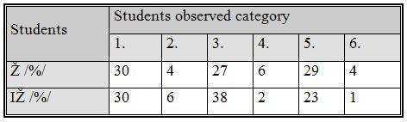

Table 5 The percentages Analysis 8 teaching units in six categories monitored
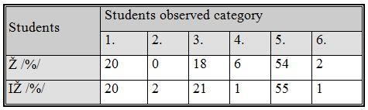
Legend:
W – Non-SEN pupils
IZ – Individually integrated pupils
1st, 2nd, 3rd, 4th, 5th, 6th. - Observed categories of Flanders
/% / - Data reported in percentages
3.3 The Individual Education and Training Plan on an exploration and theoretical -methodological basis
One of the targets for this survey was to determine whether the individual integration of pupils with mental disabilities are tought through using an IETP, who developed it, and its use in the educational process. All 14 individually integrating pupils had an IETP. In all cases, the IETP’s were compiled by class teachers. Two pupils’ IETP‘s were compiled in cooperation with the school special education teacher. All these IETP‘s but two were drawn up from the primary school curriculum (excluding some parts). In the other two cases, the IETP’s were compiled with the student‘s prior knowledge and individual skills. In the opinion of classroom teachers seven of the individually incorporated pupils corresponded to the current content of their IETP. Four individually integrated pupils and three partially responsible did not correspond with the IETP content.
Such simple understanding of the IETP requires elaborate methodical preparation and applies to the educational community as a supportive resource in educational work with pupils with special educational needs.
Recommendations for undergraduates and postgraduates in the subsequent preparation of students.
- Give more lectures and seminars for students in their first year in special education.
- Extend compulsory practice to these students in the learning plan for special-practice.
- For primary school teachers:
- The integrated students with mental disabilities should be more praised and encouraged, the negative evaluation should not take place. Increase the use of specialized educational aids including textbooks (special school for the mentally disabled).
- Make sure the pupils understand their lessons, giving commands, tasks and instructions.
- Create an integrated curriculum for pupils with mental disabilities, but not at the expense of other lessons. Certainly not during the practical classes.
- More integrated student involvement in the learning process.
- Create an IETP for mentally disabled pupils using prior knowledge and individual skills.
- Do not change plans at the expense of other curriculum lessons. Certainly not during the practical classes.
- Pair the integrated student with mental disabilities to a non-SEN classmate who is willing and able to help.
For executives regarding primary schools:
- Create a new job of special educator at each elementary school, who uses an individually integrated form of education for pupils with disabilities. Adequately assess the work of teachers with integrated pupils with mental disabilities.
From the presented data it is possible to revisit the basic theoretical information that points to the basic needs of a student with mental disabilities in terms of education and the need to inspire them in practice.
Non-SEN pupils and the inclusion of students with intellectual disabilities vary through two fundamental characteristics - intellect and ability to adapt. However, if the mentally disbabled student is able to seamlessly integrate with the non-SEN pupils, then there is no problem with integrated education. It is therefore for teachers to provide a learning platform.
Another essential task is that all school staff who use this form of education for pupils with mental disabilities, from chefs to the director, realize and try to delete persistent problems associated with integration. These include economic, material and staffing, negative attitudes of different groups of the public, problems in graph theory and practice and the actual problems in the learning process associated with the content, objectives and teaching process.
Improving the quality of education of individually integrated pupils with special educational needs is closest to inclusive education. Ideal conditions for the establishment of this type of school are not seen in general. However it would be good for national and regional conditions to make available examples of good practice (Tekelová, 2010).
4. Data and analytical research method
With the above mentioned dimensions and conclusions, influencing factors as starting points, this paper aims to offer analysis of teacher attitudes in Slovakia work in mainstream schools with individually integrated pupils with special educational needs.

4.1. Definition of research problem
Success of integration depends on the participation of all interested constituents, not just the teachers and pupils, but also by professional staff, parents, classmates. But the most important, consider is the opinion of teachers, which has a great impact on the participating. So we decided to further pursue this issue. We have set these research questions:
- What experience and attitudes have teachers with integration in the regular classroom in primary schools ?
- What about the cooperation of professional staff in the school?
- For the teacher without special-education are posibility to ask for hepl direct et school or it is necessary go and search help outside of school (for example counseling institutions: Special education teacher from development center ,Education advice, Psychologist, Psychological Counselling Centre, Teacher assistant, Speech therapist )?
- What about the experiences of teachers with disabled children and integration ?
- How much time is focused on pupils with special needs during one hour of teaching?
- Is the result of the teacher work adequate efforts made effective ?
- Integration is beneficial for inclusion of pupils with special needs ?
Research was conducted from November 2011 to February 2013 questionnaire method. Random selection of respondents was among the teachers works in the schol with handicaped and special needs pupils. The questionnaires were sent by post mail and e-mail and personaly in different regions of Slovakia ( Prešov, Košice and Žilina self-government ) in 142 primary schools and finally 368 primary school teachers participatied. The questionnaire was completed voluntarily and anonymously.
Table 6. Teaching experience of respondents
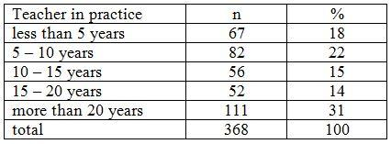
Questionnaire filled by teachers with more teaching experience in teaching practice. Filled the questionnaire more than 31% of teachers in length practice in education for over 20 years. Less than 5 years of teaching experience teachers had 18%.

Table 7. Teachers attitude preferring the school integration
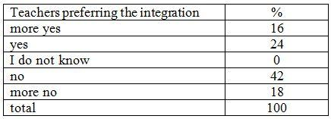
According to the laws and international regulations, the school is required to give equal opportunities for education. However, the teachers do not have the same opinions by experience, 16% of teachers said that agrees school integration. Opposite view integrating pupils into mainstream classes is expressed by 18% of teachers categorically opposes. The highest percentage 42 of respondents is against the inclusion of students in regular classes. Apparently they have bad or no teaching experience with integration and 40% agree with school integration.
Table 8. Experience teacher with integrated pupils
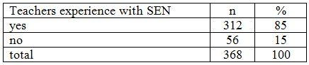
Experience in teaching practice with school integration has 85% of respondents. It follows that the group approached the respondents have sufficient information and experience with school integration in ordinary classes. It is expected that the questionnaire was filled with sufficient knowledge in the field of integration, although the teachers are not certified experts special educators.
Table 9. Number of inclusion of pupils in the classroom in primary school
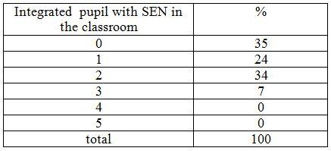
The results show that most classes are integrating the two pupils. After three pupils has incorporated at least classes and only 7% of respondents. Educators especially on the second level is expressed in an open question, the inclusion of pupils taught in several classes. To find and teach in the classroom more than 3 integrated pupils are not allowed to legisltív in practice it becomes exceptionally.

Table 10. Presence and cooperation with special educators experts directly at the school
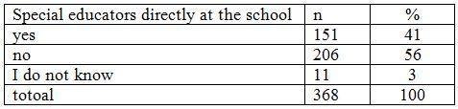
The presence of a special school teacher at the school said 41% of those surveyed teachers. Much of teachers surveyed 56% stated that such a function at the school have established
Table 11. Collaboration with experts in integration process
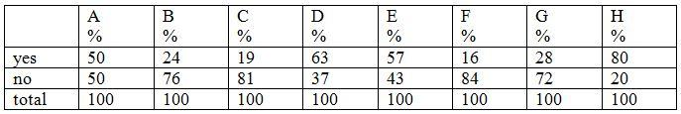
A. Special educator teacher
B. school psychologist
C. speech therapist
D. Psychologist Psychological Counselling Centre
E. special education teacher from development center
F. medical educator
G. caseworker
H. teacher assistant
The most profesional cooperation in the integration teacher provides psychologist and Psychological Counselling Centre of P and special educator from CŠPP. The biggest help in the integration of student teachers at the school is teaching assistant. The smallest collaboration with the teacher and speech therapist therapeutic educators.
Table 12. Co-operation with the assistant teacher out of the educational process at school
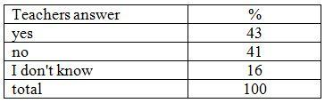
Most of the teachers cooperated 43% stated working with the assistant teacher outside teaching process – out of the educational process at schol. Outside the teaching process does not work with pupils 41% of teaching assistants. Without opinion was 16% of surveyed teachers.
Table 13. Time as a percentage devoted to integrated pupils during one lesson
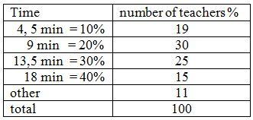
The lesson in the class is 45 minutes long. For SEN pupils nine minutes from the lesson provides 30% of teachers surveyed, 13.5 min time give them 25% of teachers surveyed, 4.5 min = 10% of the time of the lesson they provide 19% of teachers, 18 minutes dedicated attention 15 % of teachers. The teachers surveyed 11% said other alternatives: unwillingness
Cooperate from the pupil side, no time to focus on, just checking the pupils, as needed, work with the teacher assistant.
Table 14. Effect of the teacher and the adequacy of the efforts made
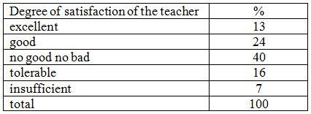
Teachers judged the outcome of its work with the inclusion of pupils at 37% for adequate development effort. The efforts of the teacher in the 23% is not a reasonable result from the SEN pupils. Asked teachers in 40% of the expressed indefinitely.
4.2. Analysis and interpretation (discussion)
The main objective of the research opinions, experiences and attitudes of teachers towards integration of students with intellectual disabilities in regular classes. Questionnaire filled the 368 primary school teachers and 31% of them has a length of teaching experience in education for over 20 years. Less than 5 years of teaching experience teachers had 18%. The respondents surveyed had NO degree in Special Education over 93%. Master's diploma for teacher in have hade 7%. respondents with a degree in special education receive more specialist approach to students with mental disabilities in integration.
Only 16% of respondents expressed a positive attitude that agrees with integration, 18% of teachers against the inclusion of SEN pupils into regular classes is. The highest percentage of 42% are against the inclusion of SEN pupils into regular classes. These teachers have bad experiences or no teaching experience with integration.
Of those surveyed, 40% of educators are advocate of school integration. Experience in teaching practice with school integration has 85% of respondents. Only 15% have no past experience with integrating pupils. It follows that the group approached the respondents have sufficient information and experience with school integration in ordinary classes. We can reasonably assume that the questionnaire was filled with sufficient knowledge of the subject.
In this school year 65% teachers surveyed work with the inclusion SEN pupils, 35% of surveyed teachers in this school year has no integrated pupils in the classroom.
The survey shows that 35% of surveyed teachers in the classroom has integrated students, 24% have only one pupil in the class, most frequently are in classes integrated two pupils confirmed that 34% of surveyed teachers. After three inclusion of pupils in the class has 7% of respondents. Educators especially on the second level are expressed in an open question, the inclusion of pupils taught in several classes, which is in line with current legislation.
The teachers surveyed, 41% reported the presence of a expert for special educationdirect at the school, 56% of respondents has NO established a function for special pedagogue direct at schol they must go and look for professional help outside from the school. The rest 3% of the surveyed teachers have no idea. Most professional collaboration during the integration provide with teachers counseling psychologist of 63% and a special educator from the 57%. The biggest help for teachers provide teaching assistant, which is expressed by 80% of the surveyed teachers. Smallest cooperation with the speech therapist is 19% and 16% curative educators. With school special education teacher works in 50% of respondents, with 24% of school psychologists.
We further investigated the place where runn the collaboration. Assistant cooperation with inclusion of pupils outside of the educational process mentioned 43% of teachers. Outside the teaching process does not work with pupils 41% of teaching assistants. No opinion 16% of surveyed teachers. Teachers judged the result of its work with the inclusion of pupils with SEN at 13% for adequate development effort. To the question, 24% of respondents said yes rather than no. The efforts of the teacher in 7% is not a reasonable result from the student, 16% of respondents to the question expressed more no than yes. To this question 40% of respondents had no strong opinion.
Focus and attention for the integrated pupils with SEN, 9 minits time from the lesson provide usually 30% of surveyed teachers, 30% = 13 minits of the time they provide 25% of teachers, 10% = 4 – 5 minits of the time of the lesson they provide 19% of teachers, 40% = 18 minits of the time they provide 15% of teachers. The teachers surveyed 11% said other alternatives.
From the research that implement the integration of the schools will be successful if it will be involved all elements of school management, professional educators, teachers, students integrate their classmates and parents.
5. Conclusion
Values that teachers profess to reflect often on their students in social, but also working relationship. Become a model for pupils , whether they like it or not .
The aim of integration on the one side, the most successful socialization and also the adoptation of SEN pupils. Integration is a long, complex and highly sensitive process. Students are becoming more sensitive, awakens in them human feelings.
Integration from the perspective of special education teachers is a natural process. From the primary school teacher's point of view - they must implemented it in practice with many uncertainties and questions that arise. In practice, we often meet with rejection rather than the process of acceptance. The current legislation has created very favorable conditions for the successful implementation of integration. It's not only about the process itself teacher cooperate with the whole team of experts.
Since the management of the school through special education teaching professionals who have sufficient knowledge for implementation and integration. Within the region, the number of expert advisors is very low, for the professional help teachers are waiting a very long time. Visits and consultation of experts from the pedagogical - psychological counseling and prevention and development center - special pedagogical counseling does not allow solving everyday problems of education of students. Education Act proposes to establish a special function for expert who work direct at the school and especially helpful when integrated pupils or teacher or parents need a help. Implement this function in practice is still at an early stage.
The successful integration of the course must be involved also a parent of the child. Activity on the part of parents can raise a more positive public awareness of integrated education . School integration must be carried out in accordance with applicable standards . Integration is still in the best researched academic process . Joint training is necessary for children with and without special needs . Society needs people with different abilities . Education through the integration of ensuring the development of all children - with talent , with intellectual or physical disabilities . For successful integration must not forget the essentials - baby , which we all gladly assist. Helping all children let their dreams come true.

References
Bajo, I., Vašek, Š. 1994. Pedagogika mentálne postihnutých. Bratislava : Sapientia, 1994. ISBN 80-967180-1-0.
Danielsová, E., Stafordová, K. 2002. Vytváranie integrovaných tried. Žiar nad Hronom : Nadácia Škola dokorán, 2002. ISBN 80-968292-9-7.
Flanders, N. A. 1970. Analyzing teaching behavior. Reading. Addison – Wwesley, 1970.
Hájková, V., Strnadová, I. 2010. Inkluzivní vzdělávání. 2010. ISBN 978-80-247-3070-7.
Jesenský, J. 2000. Základy komprehenzivní speciální pedagogiky. Hradec Králové : Gaudeamus, 2000. ISBN 80-7041-191-1.
Lang, G., Barberichová, Ch. 1998. Každé dítě potřebuje speciální přístup. Praha : Portál, 1998. ISBN 80-7178-144-4.
Lechta, V. 2009. Komponenty inkluzívnej pedagogiky. In LECHTA, V. (ed.) Východiská a perspektívy inkluzívnej pedagogiky. Martin : Vydavateľstvo Osveta spol. s r.o., 2009. ISBN 80-8063-303-5.
Müller, O. Et. Al. 2001. Díte se speciálními vzdelávacími potřebami v bežné škole. Olomouc : Univerzita Palackého v Olomouci, 2001. ISBN 80-244-0231-9.
Průcha, J., Walterová, E., Mareš, J. 1995. Pedagogický slovník. Praha : Portál, 1995. ISBN 80-7178-252-1.
Tekelová, M. 2012. Od školskej integrácie k inklúzii z legislatívneho hľadiska. In LECHTA, V. (ed.) Výchovný aspekt inkluzívnej edukácie a jeho dimenzie. Bratislava : PhDr. Milan Štefanko – IRIS, 2012. ISBN 978-80-89256-89-1.
Vanćová, A. .2005. Základy pedagogiky mentálne postihnutých. Bratislava: Sapientia, 2005. ISBN: 80 – 9687973636
Vygotskij, 1976. Vývoj vyšších psychických funkcí. 1. vyd. Praha : SPN, 1976.
Zelina, M., Furman, A. 1986. Metodika psychologickej analýzy vyučovacích hodín. In : Psychológia a patopsychológia dieťaťa, 1986, č. 4, s. 321 – 332. ISSN 0555-5574.
Documents
Vyhláška Ministerstva školstva, mládeže a športu SR č.29/1990 Zb., ktorou sa dopĺňa
Vyhláška Ministerstva školstva Slovenskej socialistickej republiky č. 143/1984 Zb. o základnej škole.
Vyhláška Ministerstva školstva, mládeže a športu SR č. 80/1991 Zb. o stredných školách.
Vzdelávací program pre žiakov s mentálnym postihnutím ISCED 1.
Zákon č. 29/1984 Zb. o sústave základných a stredných škôl (školský zákon).
Zákon č.365/2004 Z. z. o rovnakom zaobchádzaní v niektorých oblastiach a o ochrane pred diskrimináciou a o zmene a doplnení niektorých zákonov (antidiskriminačný zákon).
Zákon č. 245/2008 Z. z. o výchove a vzdelávaní (školský zákon) a o zmene a doplnení niektorých zákonov.

Catholic university in Ružomberok (Slovakia)
University of Prešov, Prešov (Slovakia)

